# Web JAVA

Real life examples

Statement – GSM mobile

PreparedStatement – CDMA mobile

Asynchronous – restaurant order

Synchronous – grocery market

Authentication – passport entry to hotel

Authorization – elevator with id card(are allowed to perform this action, no need of name)

1. In software development, a **runtime** **environment** is a collection of hardware and software tools that a system developer uses to build software systems eg kitchen.
2. The Java compiler takes the source code and produces bytecode, which is then executed by the Java Virtual Machine (JVM). The bytecode is loaded into the JVM, and the JVM interprets the bytecode and executes the program

# JDK/JRE/JVM

JVM(Java Virtual Machine) acts as a run-time engine to run Java applications. JVM is the one that actually calls the main method present in a java code. JVM is a part of JRE(Java Runtime Environment).

Java applications are called WORA (Write Once Run Anywhere). This means a programmer can develop Java code on one system and can expect it to run on any other Java-enabled system without any adjustments. This is all possible because of JVM.

When we compile a .java file, .class files(contains byte-code) with the same class names present in .java file are generated by the Java compiler. This .class file goes into various steps when we run it. These steps together describe the whole JVM.

1. JDK (Java Development Kit) is a software development environment which is used to develop Java applications and applets. It physically exists. JDK is a kit that includes two things

* Development Tools(to provide an environment to develop your java programs) eg. Javac, javadocs, java, jar
* JRE (to execute your java program).

2. JRE (Java Runtime Environment) is an installation package that provides an environment to only run(not develop) the java program(or application)onto your machine. JRE is only used by those who only want to run Java programs that are end-users of your system.

3. JVM (Java Virtual Machine) is a very important part of both JDK and JRE because it is contained or inbuilt in both. Whatever Java program you run using JRE or JDK goes into JVM and JVM is responsible for executing the java program line by line, hence it is also known as an interpreter.

Abstraction

1. **Abstraction can be defined as hiding unwanted details while giving out the most essential details.**
2. Abstraction hides details at the design level.
3. Abstraction lets you focus on WHAT the object does instead of how it does.
4. Abstraction focuses on outer lookout e.g. moving of vehicle.
5. In Java, Abstraction is supported using the interface and abstract class.
6. Abstraction means extracting common details or generalizing things.
7. Abstraction aims at hiding the implementation detail

Whenever we want to hide the unimportant data, like we don't want others to know what our internal classes are doing 🡺 We use Abstraction

For example, when you first describe an object, you talk in more abstract terms e.g. a Vehicle that can move, you don't tell how the Vehicle will move, whether it will move by using tires or it will fly or it will sell. It just moves. This is called Abstraction. We are talking about the most essential thing, which is moving, rather than focusing on details like moving in-plane, sky, or water.

Example 1 – We all have been using ATMs. And if we want to withdraw the money from that then we simply interact with the Use Interface Screen where we have been asking for details.

Example 2 - pow(), min(), max(), etc. are there, and we are only using that to get our result. It’s not the case where we check its implementation. So it is also an abstraction.

Example 3 - Great example of abstraction, JDBC java. SQL package. Full of interfaces

Features of Abstraction –

* Improves Easiness- It helps to use the features without knowing implementation so it improves easiness for the users to use that.
* Maintainability will improve- Without affecting the user, it can able to perform any types of changes internally. So, maintainability will improve.

Encapsulation aims at hiding data while abstraction aims at hiding the implementation detail.

Encapsulation

1. **Encapsulation means binding the code and data into a single unit e.g. class or method to protect the inner working of an object from the outside world.**
2. Encapsulation hides details at the implementation level.
3. Encapsulation means hiding the internal details of how an object works. When you keep internal working details private, you can change them later with a better method.
4. Encapsulation focuses on internal working or inner lookout e.g. how exactly the vehicle moves.
5. Encapsulation is supported using the class n data members with access modifiers e.g. public, private, and protected.
6. Encapsulation aims at hiding the data

Whenever we want to hide some important data in order to protect our data present inside a class 🡺we use data class i.e. (Encapsulation)

Data Hiding – It means hiding the data of the class and restricting access to the outside world. Like Using the access specifier keywords like private that restricts the data to only accessible and modifiable in the same class. Outside users cannot access the data.

Example 1- In the market, Capsules are available to cure different medical problems. In that capsules, there are different chemicals are grouped to make a complete medicine. So the grouping of that compositions into a single unit in the capsule is a form of encapsulation.

Example 2- In a car, we have all the required things to make a car complete. Like engines, gear shift, wheels, etc. and these are grouped into a single body that makes a car. Everything is grouped into a single body.

Example 3- example of a LinkedList. We create a node that contains data and this node is related to the LinkedList class. And Operation on that node like – Add, Delete, Search, etc. are grouped into a single class.

Features of Encapsulation –

* It provides extra security by the concept of Data Hiding.
* It groups the data and operation into a single unit.
* It attaches an extra security layer to the data and allows to access data only to authorized ones.

Inheritance

**Inheritance is the method of acquiring features of the existing class into the new class.** Suppose there is a class, considered as the parent class, that has some methods associated with it. And we declare a new class, considered as the child class, that has its own methods. So, when a child class is inherited from the parent class then it will have all the methods associated with parent class are available in the child class along with the child class own methods also. So that is Inheritance.

Example 1 – Similarly, in software, regular updates are with some new features are also the inheritance.

The biggest advantage of inheritance is code reusability.

Polymorphism

Polymorphism is the most essential concept of the Object-Oriented Programming principle. It has meaning ‘poly’ – many, ‘morph’ – forms. So, polymorphism means many forms.

In Object-Oriented Programming, any object or method has more than one name associated with it. That is nothing but polymorphism.

For Methods – Methods can also have multiple names associated with them. That we also consider as the types of polymorphism.

OOPs states 2 types of Polymorphism –

Compile Time Polymorphism. Also called Static binding.

Runtime Polymorphism. Also called Dynamic binding.

Que. What is the matter of using getters and setters if we can access it from outside.

The reason for using getters and setters instead of making your members public is that it makes it possible to change the implementation without changing the interface. Also, many tools and toolkits that use reflection to examine objects only accept objects that have getters and setters.

Que. Can main method be overridden in java?

No, the main method cannot be overridden in Java. This is because the main method is a static method, and static methods cannot be overridden. Overriding is a feature of object-oriented programming that allows a subclass to provide its own implementation of a method that is inherited from a superclass. However, static methods are not associated with any particular object, so they cannot be overridden.

The main method is the entry point for a Java program, and it is responsible for initializing the program and starting its execution. The main method is declared as follows:

public static void main(String[] args

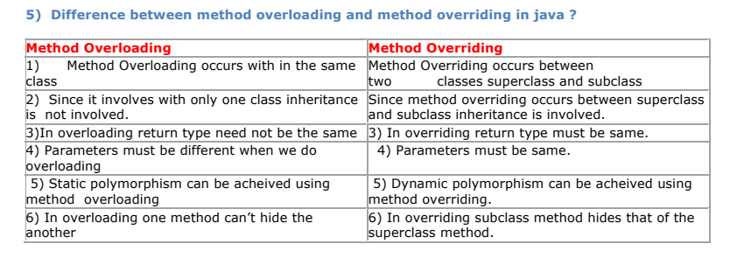

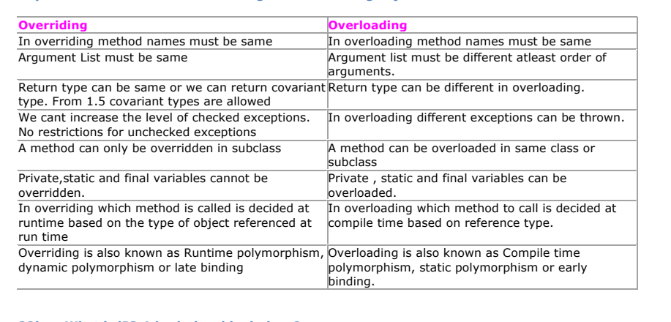

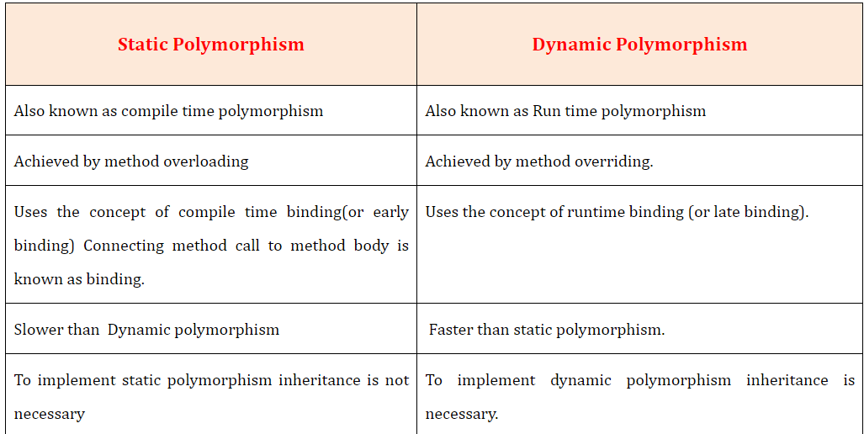

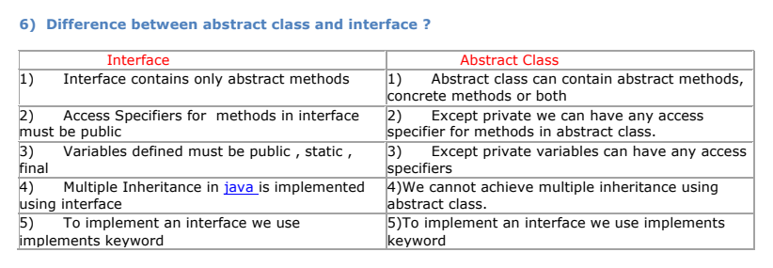

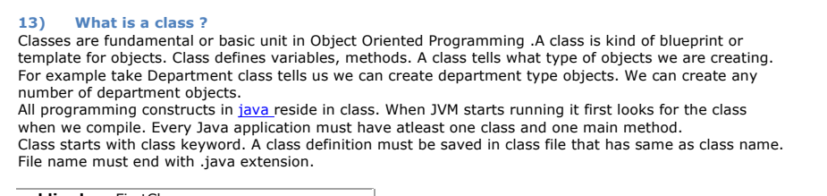

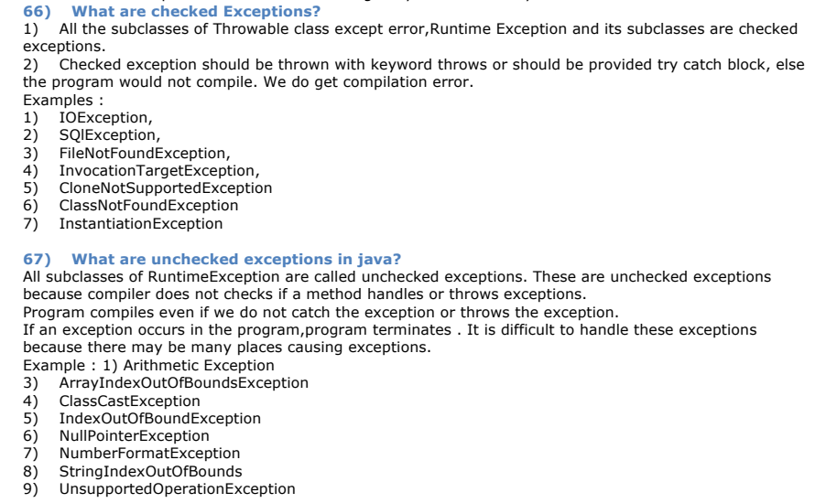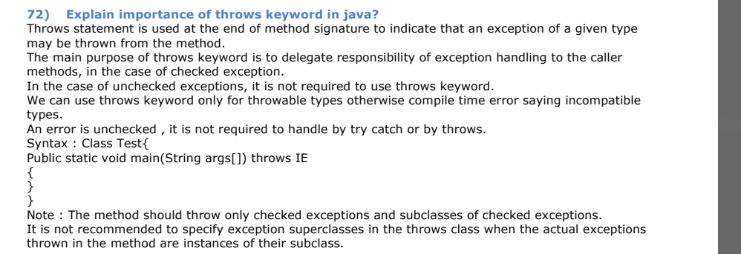

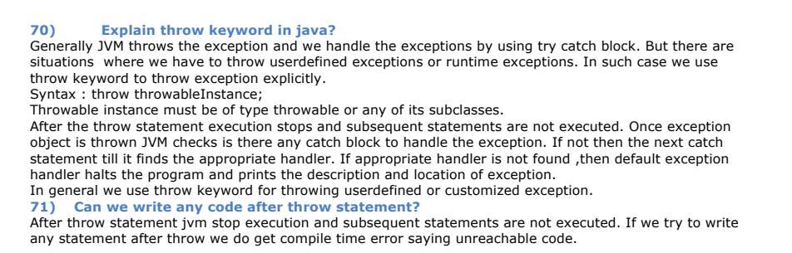

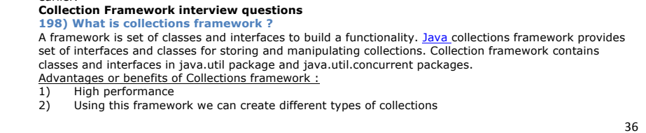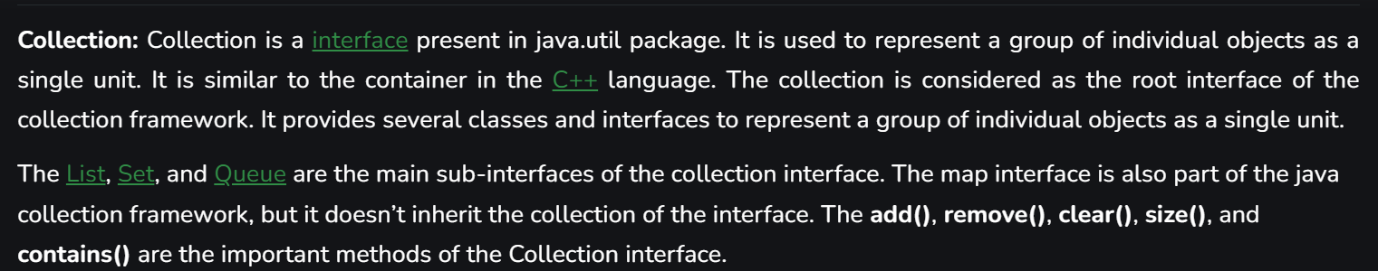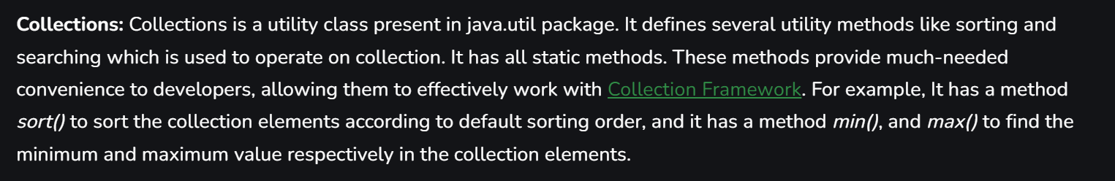

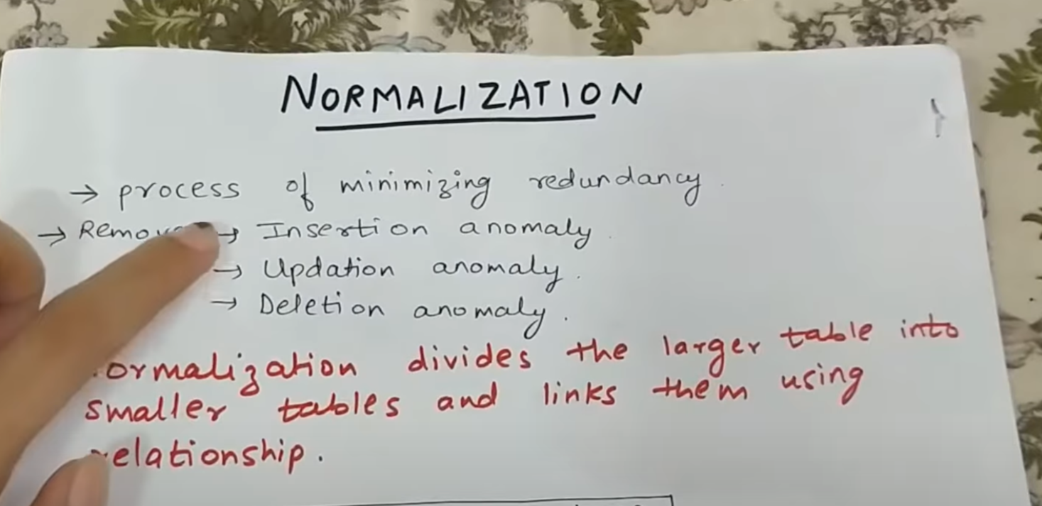

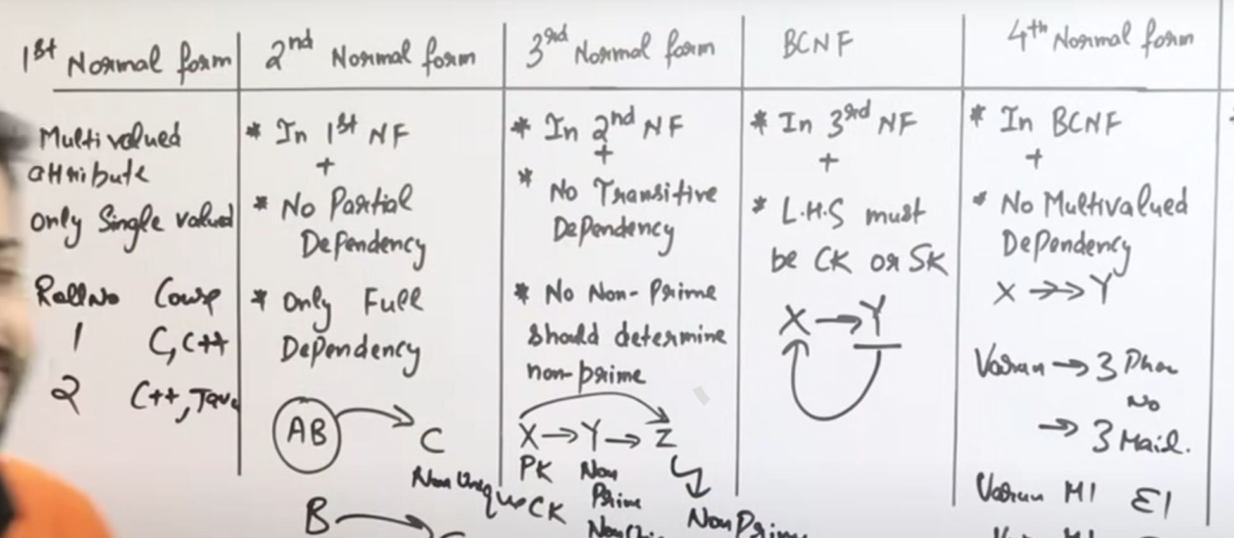

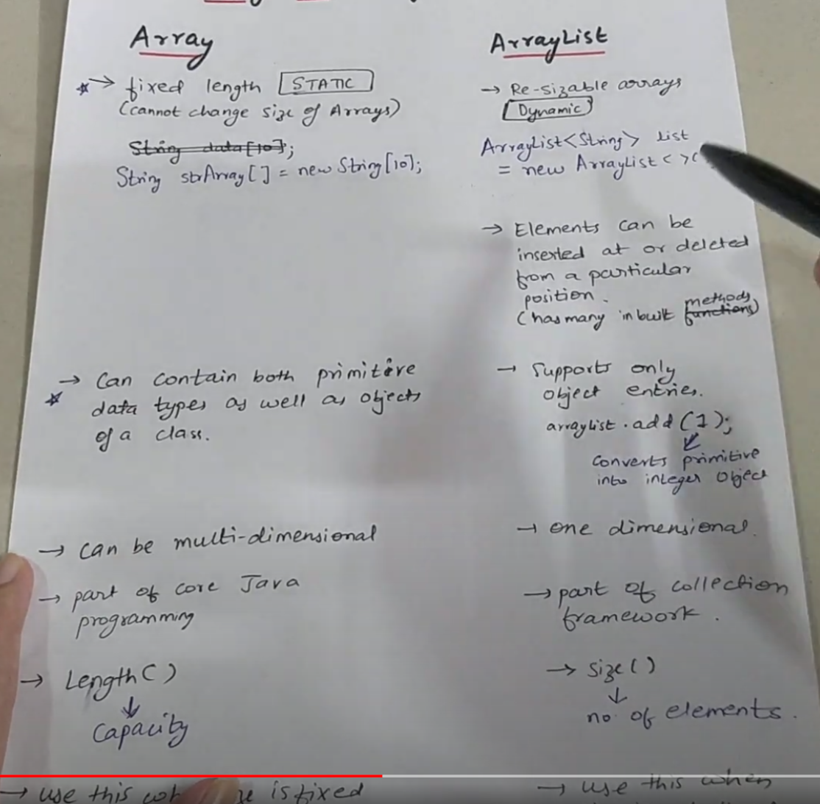

Thymeleaf - is a Java template engine that is used to create HTML, XML, JavaScript, CSS, and text templates. It is a server-side template engine, which means that the templates are processed on the server before being sent to the client. Thymeleaf is designed to be easy to use and to produce natural-looking templates.

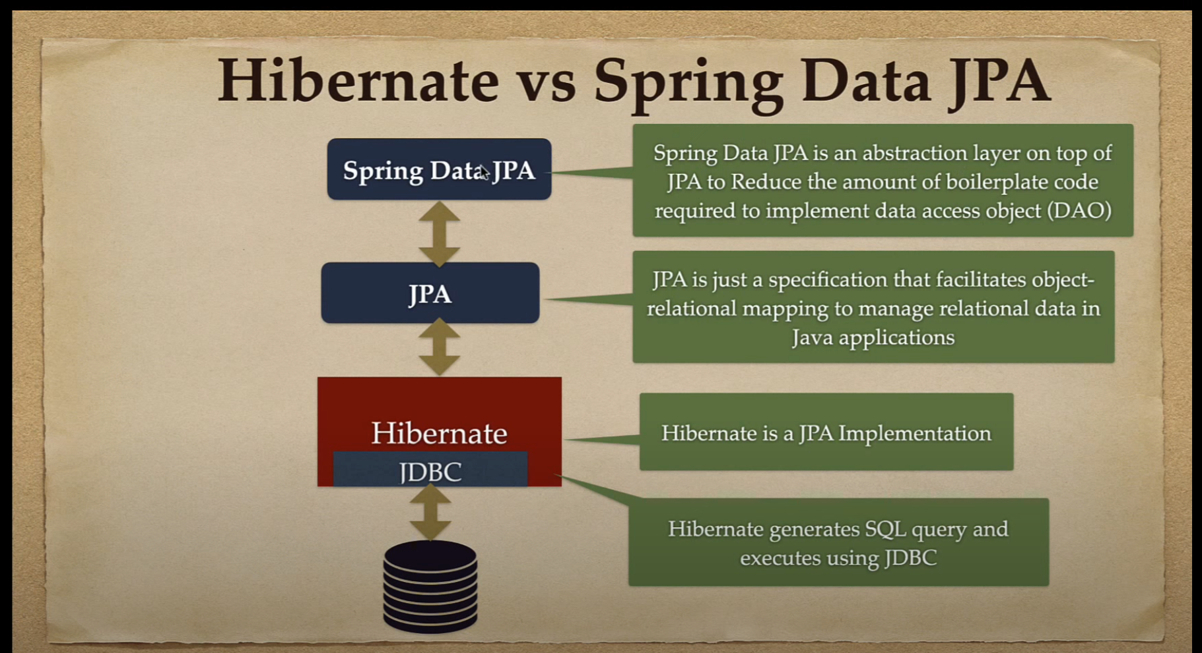

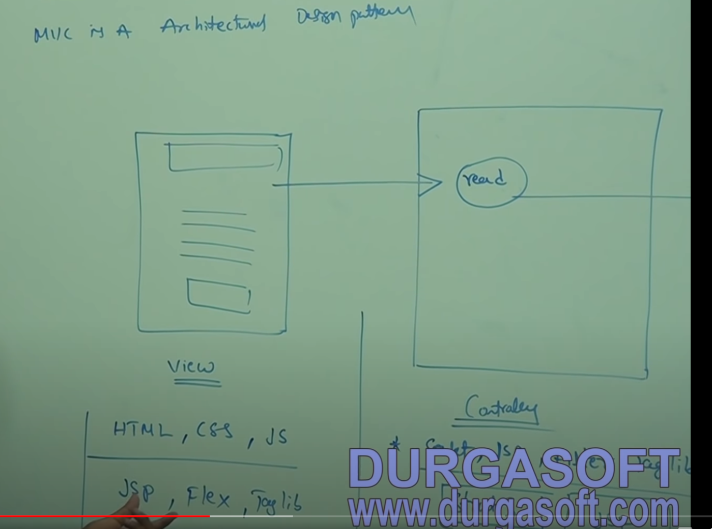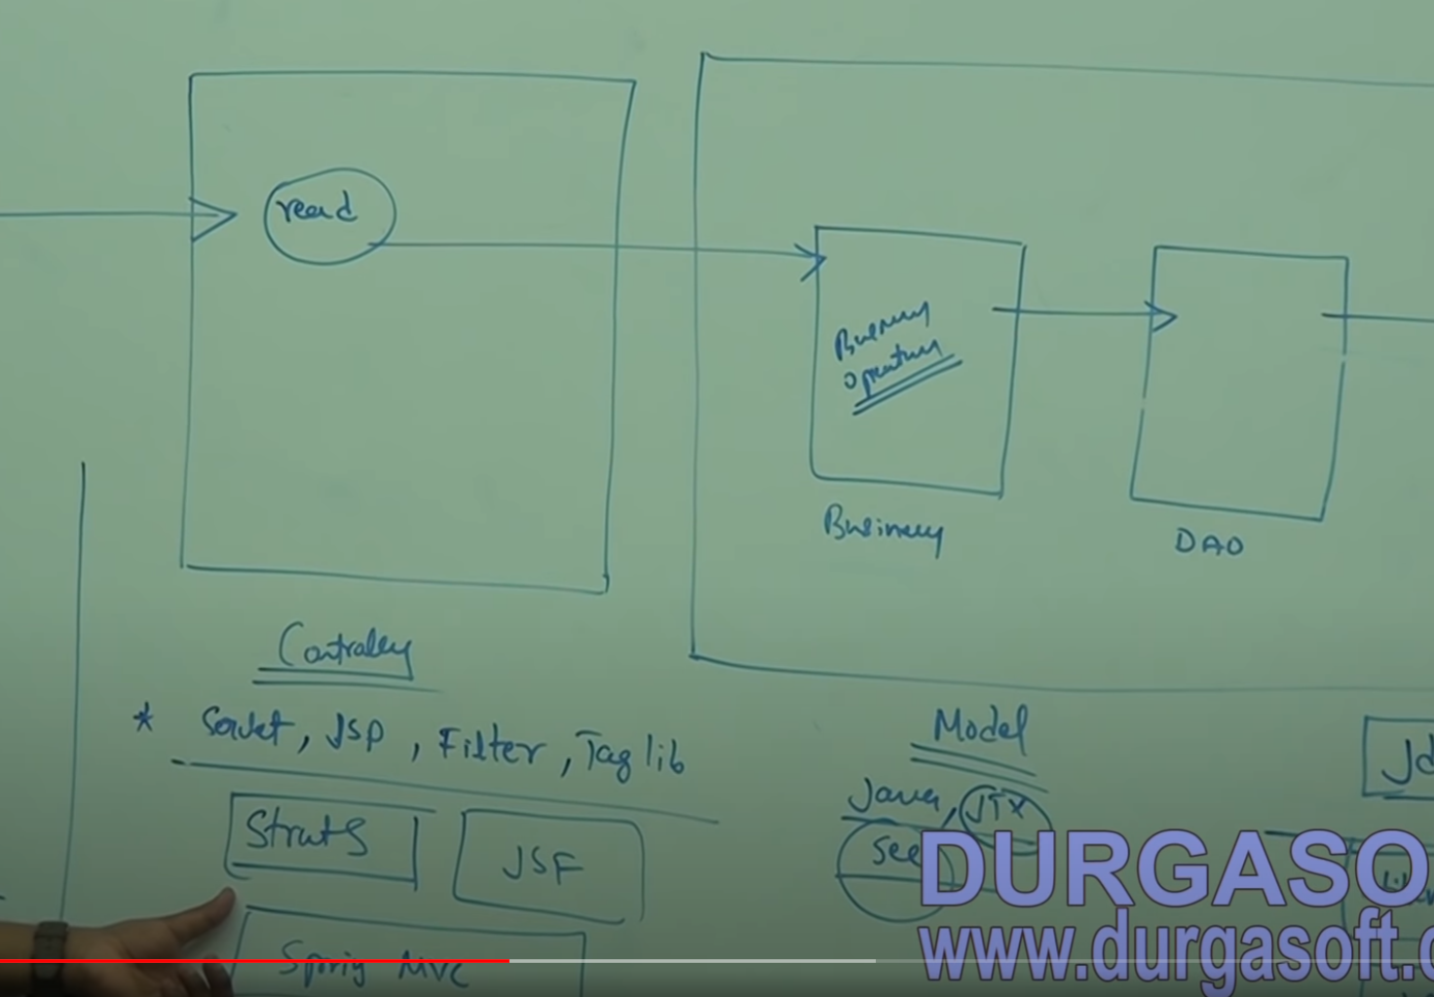+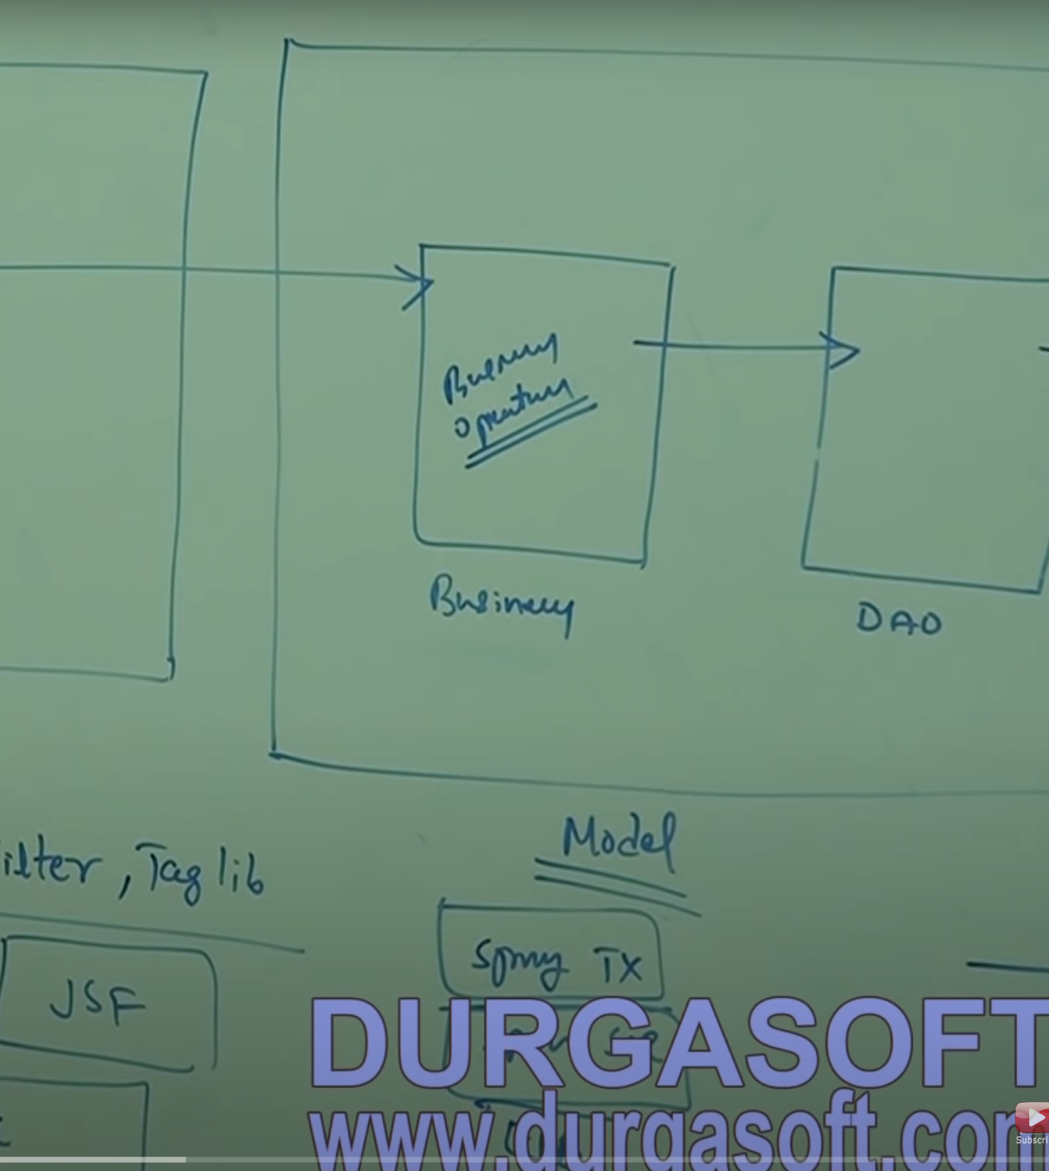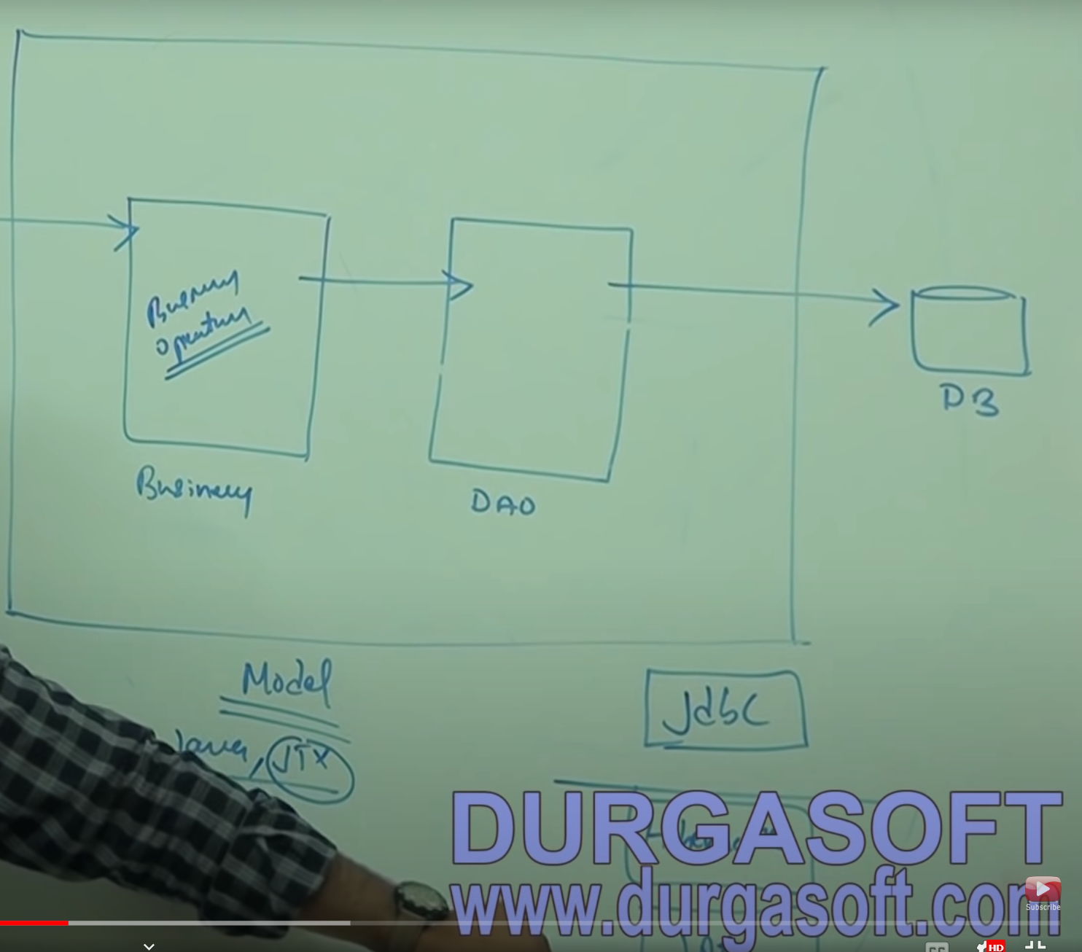

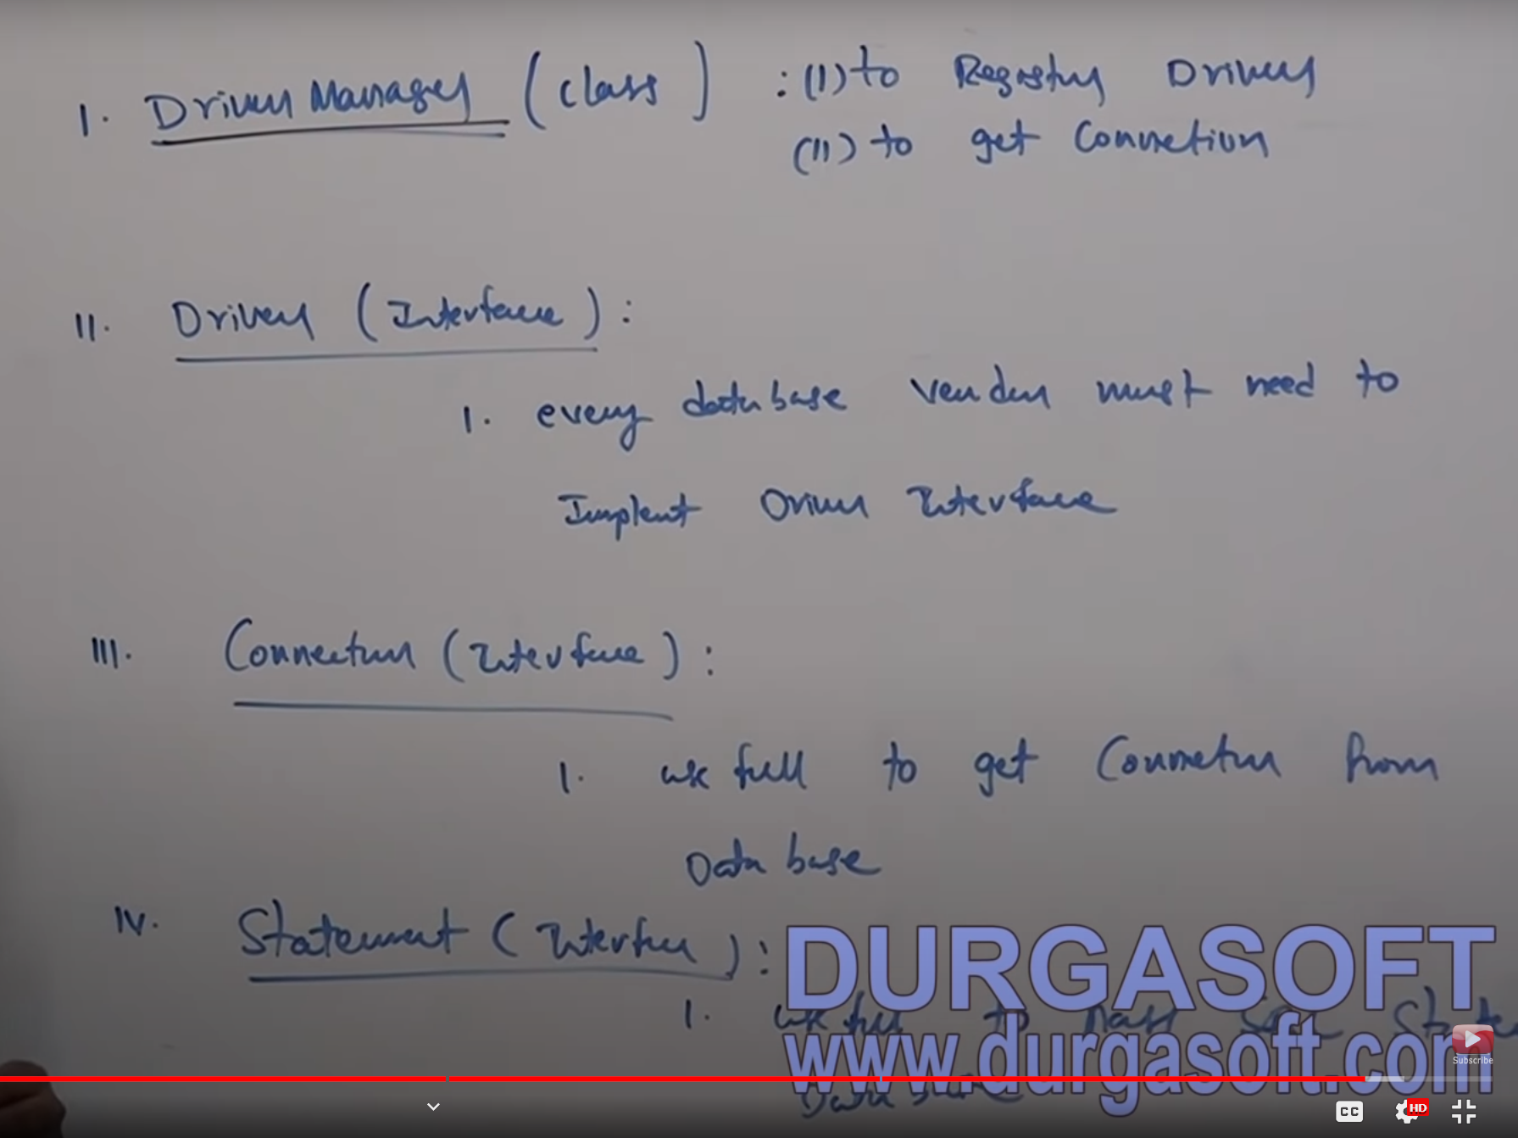

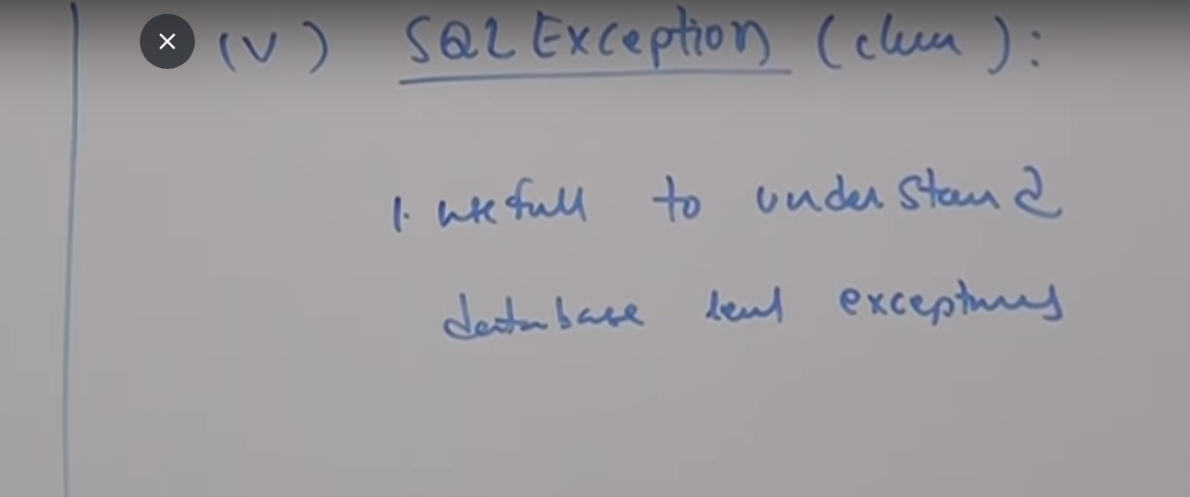

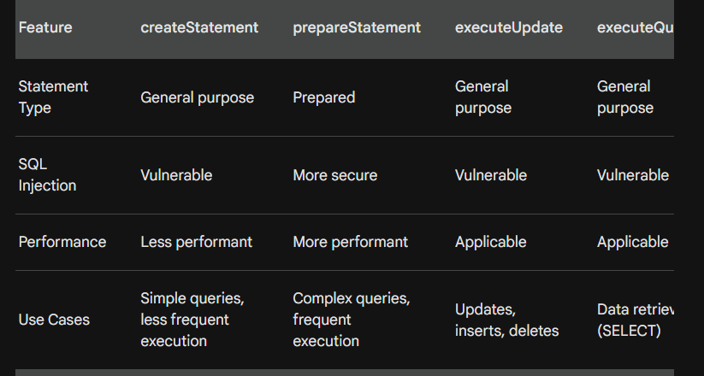

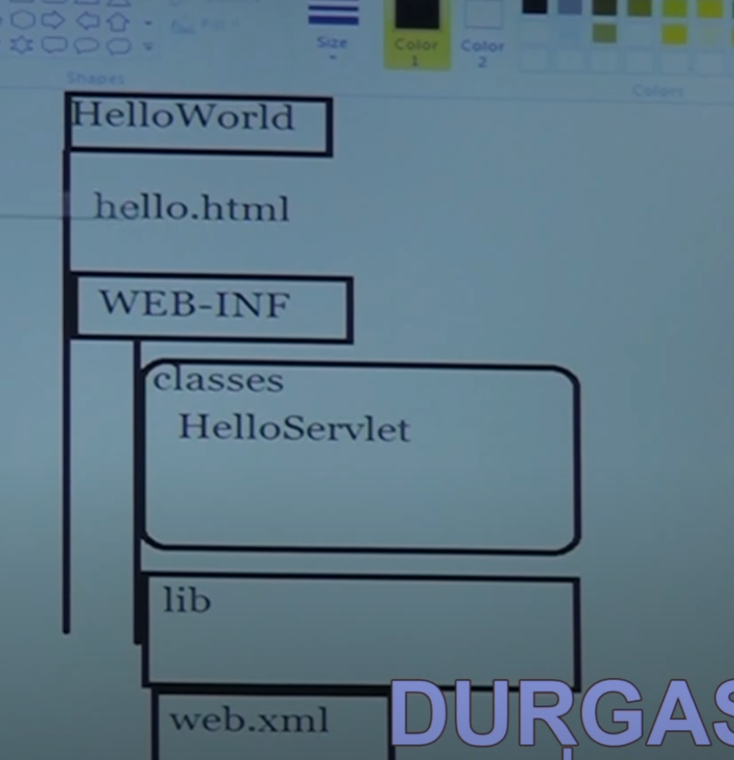

Hibernate features

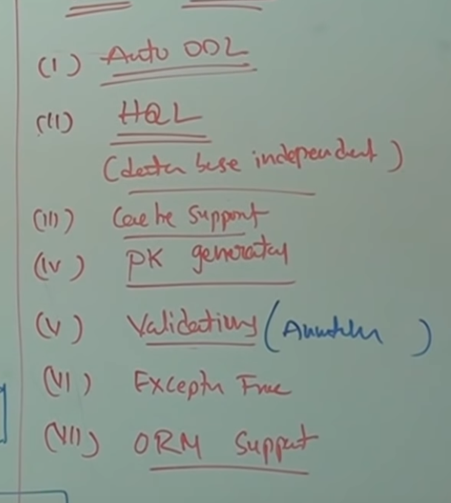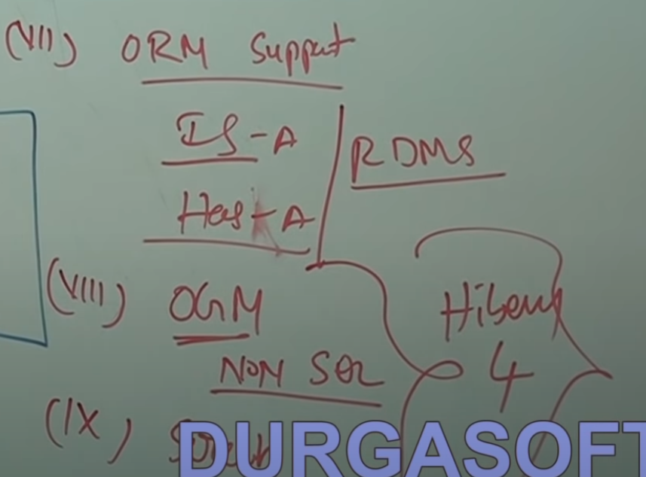

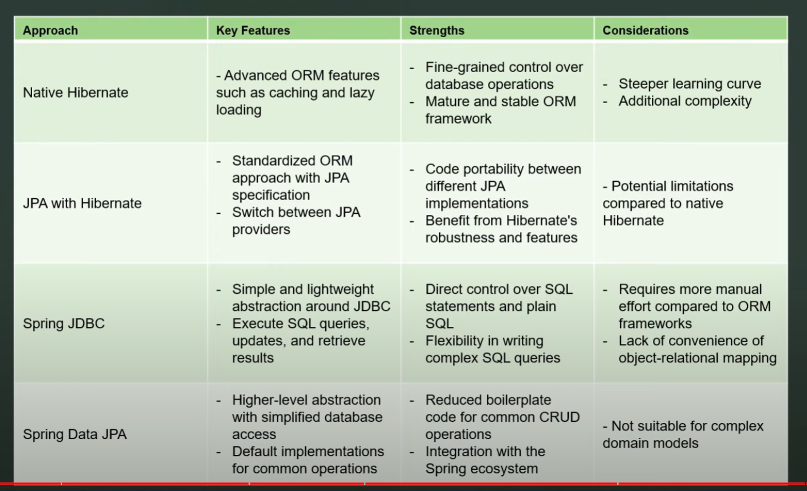

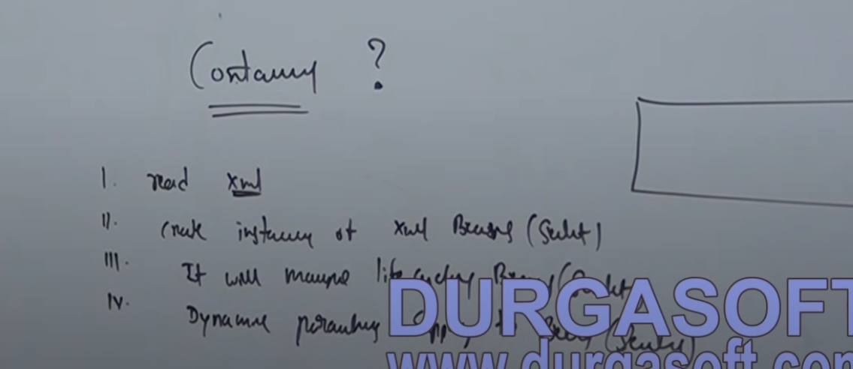

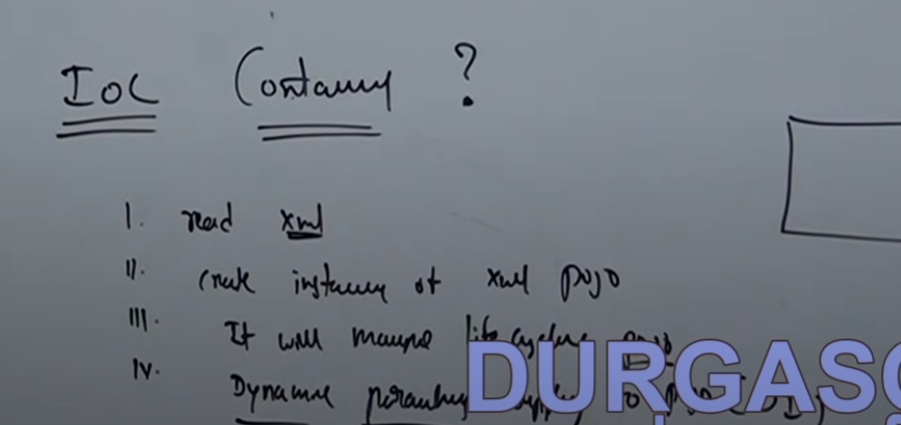

DI is main asset of IOC container

DI : At runtime it will read input from xml and Pass req input data from xml file to your POJO files

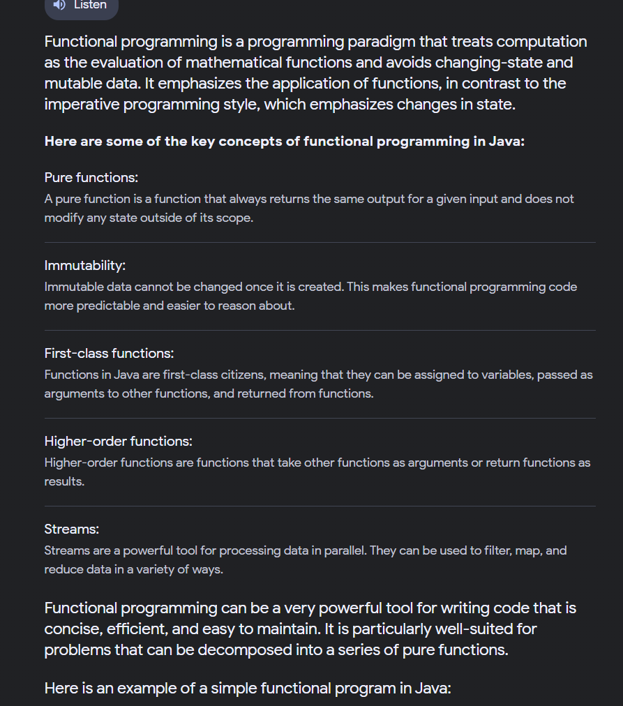

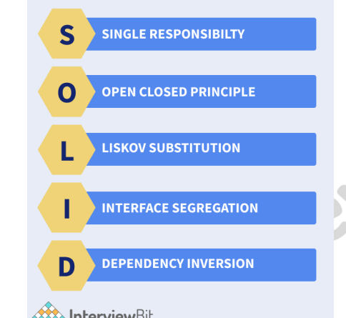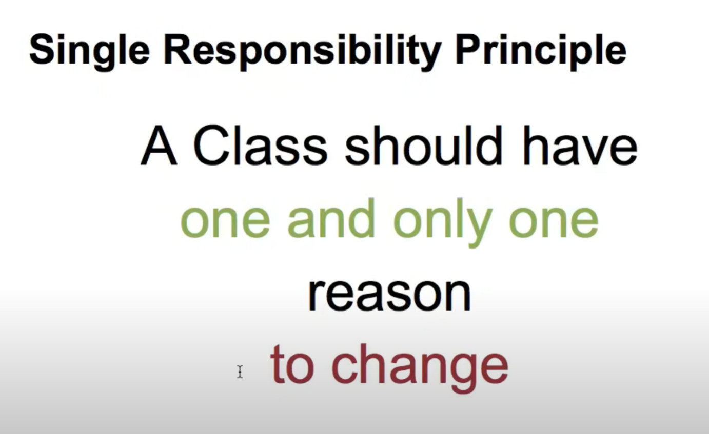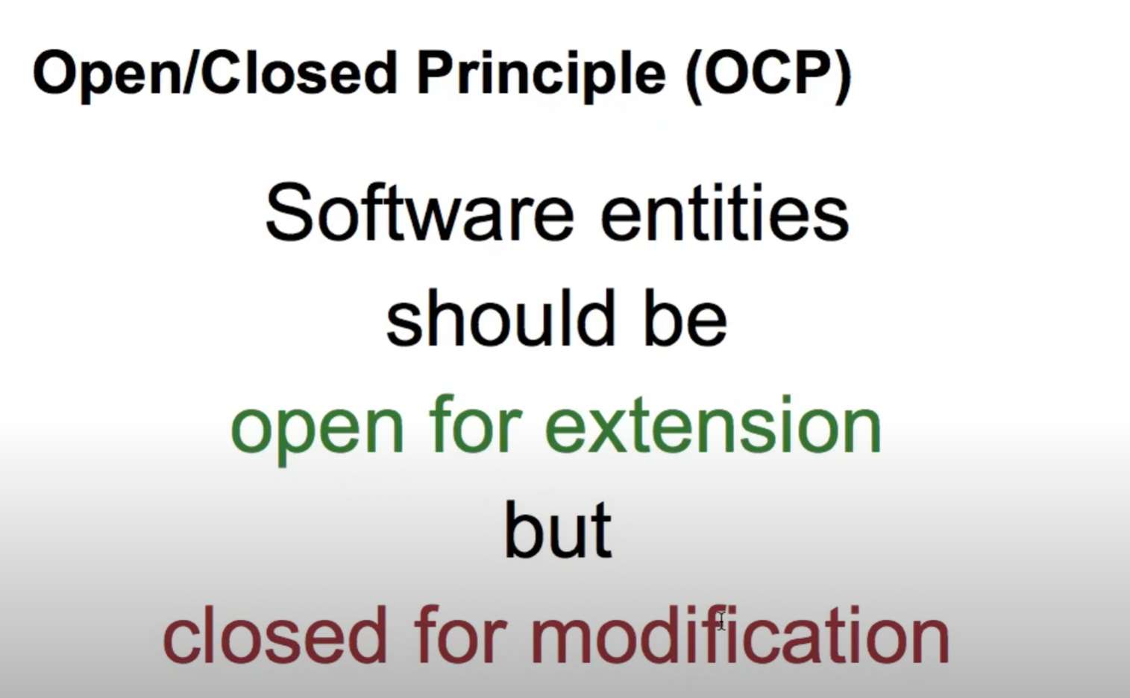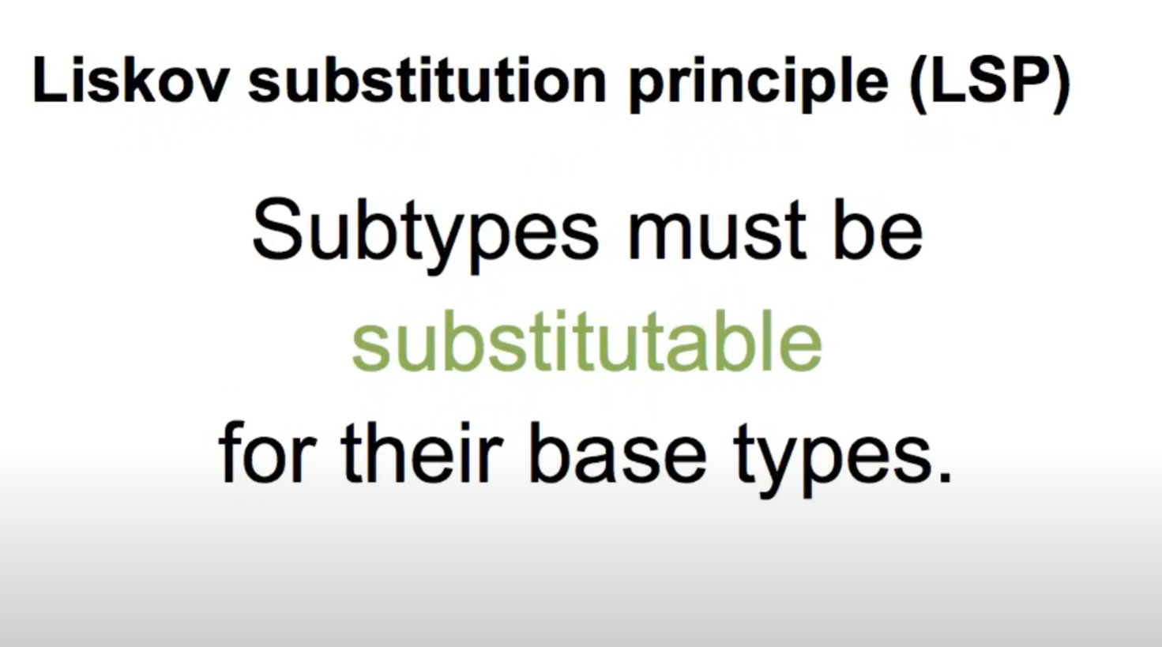

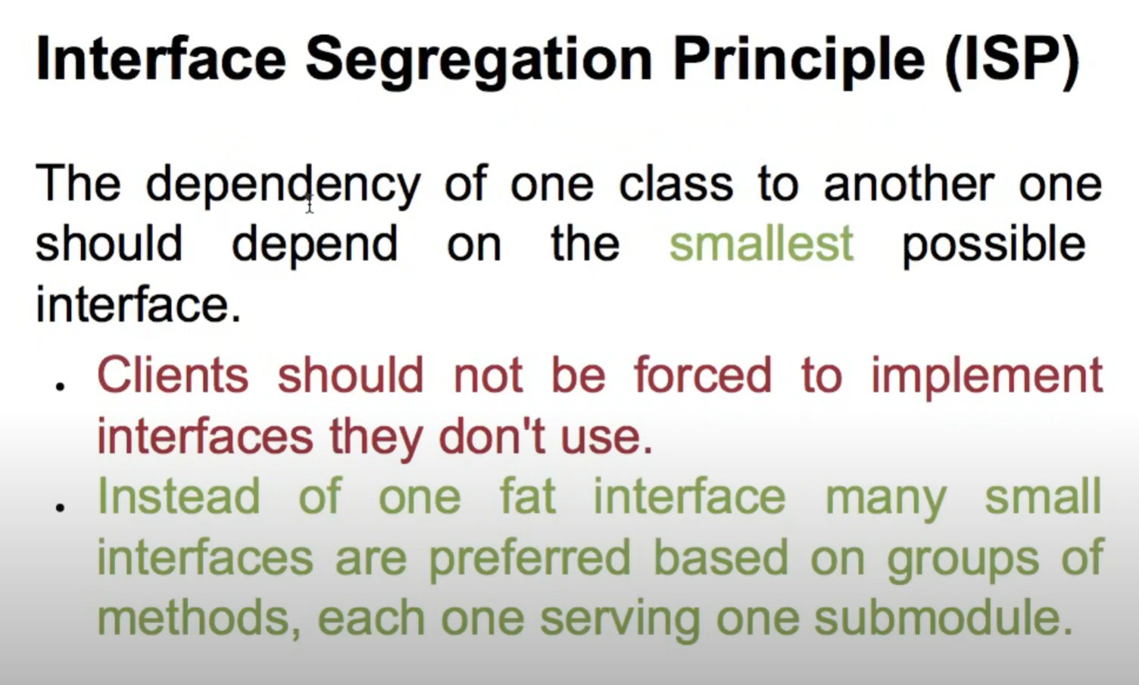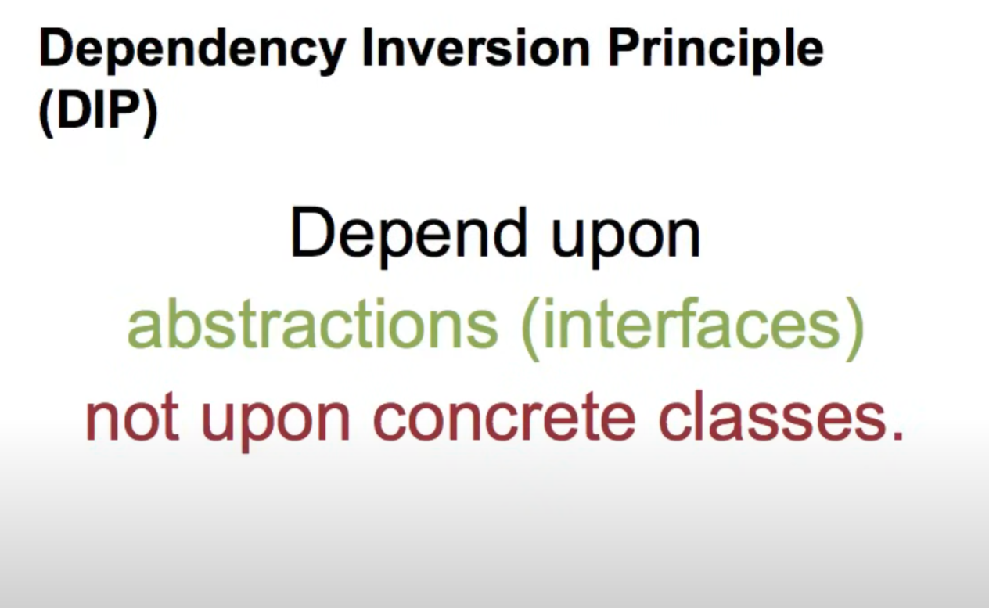

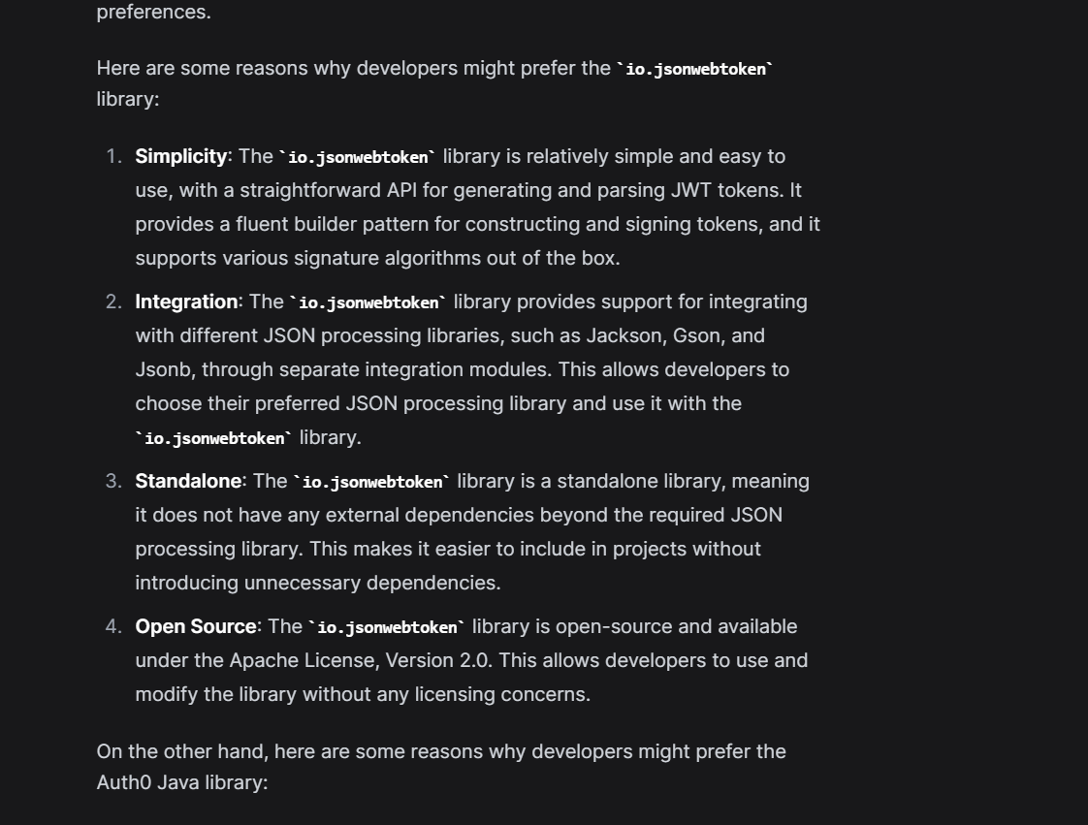

<https://www.linkedin.com/pulse/demystifying-database-access-java-jpa-hibernate-jdbc-ali-gb7uf/>

1. Java Persistence API (JPA): An Overview

JPA is a specification that defines a standard interface for Java applications to interact with relational databases. It simplifies database access by providing a set of annotations and APIs for mapping Java objects to database tables. JPA is not an implementation but rather a set of rules that frameworks, like Hibernate, implement.

2. Hibernate: A Robust JPA Implementation

Hibernate is a powerful and widely used Object-Relational Mapping (ORM) framework. It is a JPA implementation, meaning it adheres to the rules set by the JPA specification. Hibernate goes beyond JPA, offering additional features and optimizations. Developers often choose Hibernate when they need a full-featured ORM framework with advanced capabilities for complex database interactions.

3. Java Database Connectivity (JDBC): The Foundation

JDBC is the standard Java API for connecting to relational databases. Unlike JPA and Hibernate, JDBC is lower level and requires developers to write SQL queries and handle result sets manually. While it offers more control, it also demands more code. JDBC is often used when fine-grained control over database interactions is required, or when working with databases not covered by higher-level frameworks.

4. Spring Data: Simplifying Data Access with Spring

Spring Data is part of the larger Spring Framework and provides a higher-level abstraction for data access. It supports various data sources, including relational databases, NoSQL databases, and more. Spring Data JPA, a module within Spring Data, integrates seamlessly with JPA and Hibernate, reducing boilerplate code and simplifying common database operations. It allows developers to use repositories and query methods, promoting a more declarative and less procedural approach.

5. Comparing JPA, Hibernate, JDBC, and Spring Data

JPA vs. Hibernate:

* JPA: A specification defining a set of rules for Java applications to interact with databases.
* Hibernate: A full-fledged ORM framework implementing the JPA specification with additional features.

JPA vs. JDBC:

* JPA: Higher-level abstraction with object-relational mapping, reducing the need for manual SQL.
* JDBC: Lower-level API requiring manual SQL queries and result set handling.

Hibernate vs. JDBC:

* Hibernate: An ORM framework providing higher-level abstractions, automatic table creation, and caching.
* JDBC: Direct and low-level database access, offering more control but demanding more manual coding.

Spring Data vs. JPA/Hibernate:

* Spring Data: Part of the Spring ecosystem, providing a simplified and consistent approach to data access.
* JPA/Hibernate: Lower-level frameworks with richer features but potentially more boilerplate code.

6. How They Relate:

* JPA and Hibernate: Hibernate is a JPA implementation. Developers often use the terms interchangeably, but it's essential to recognize that Hibernate extends JPA with additional features.
* JPA and JDBC: JDBC is the lower-level foundation that JPA builds upon. JPA simplifies database access by introducing object-relational mapping and higher-level abstractions.
* Hibernate and JDBC: Hibernate abstracts JDBC, providing a higher-level API for developers. While JDBC is manually code-intensive, Hibernate automates many aspects of database access.
* Spring Data and JPA/Hibernate: Spring Data simplifies data access by providing a unified interface for various data sources. Spring Data JPA, specifically, integrates seamlessly with JPA and Hibernate, reducing boilerplate code.

Here, the @Component annotation marks our classes as beans.

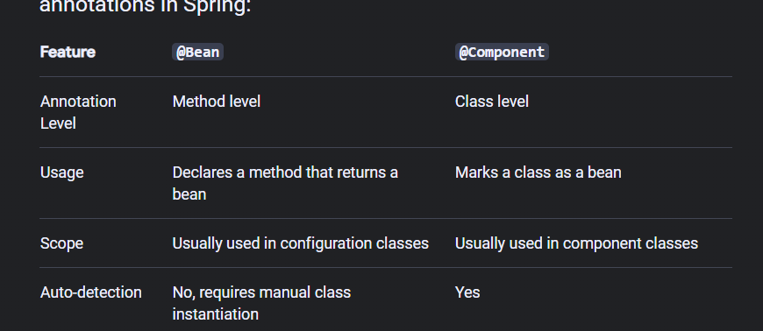

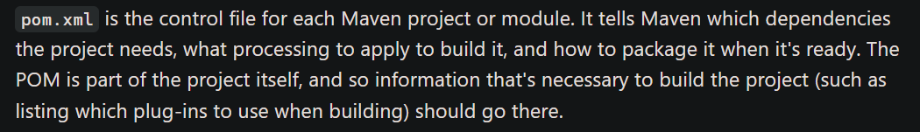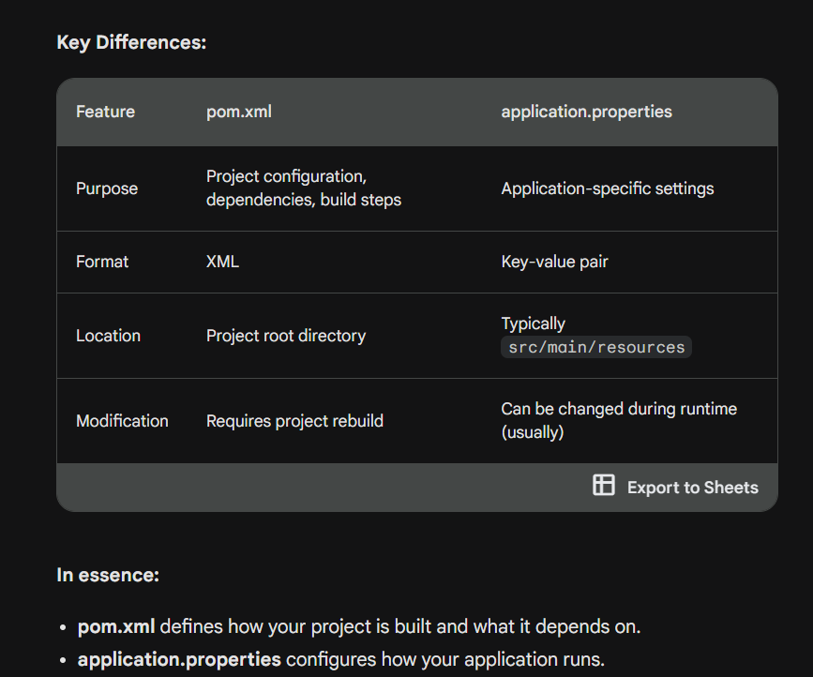

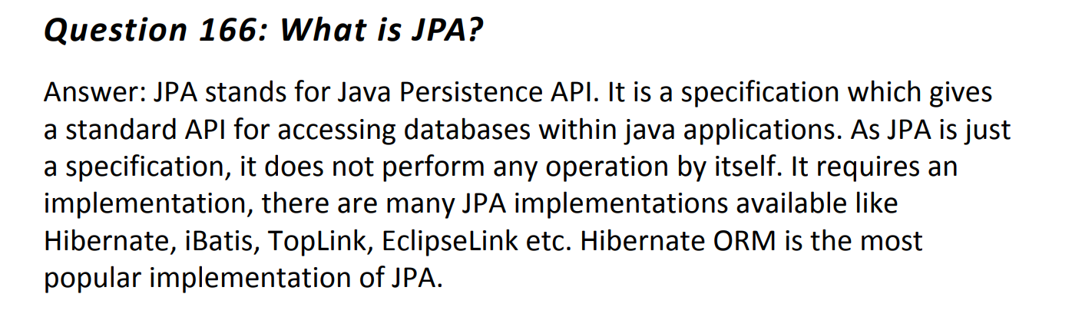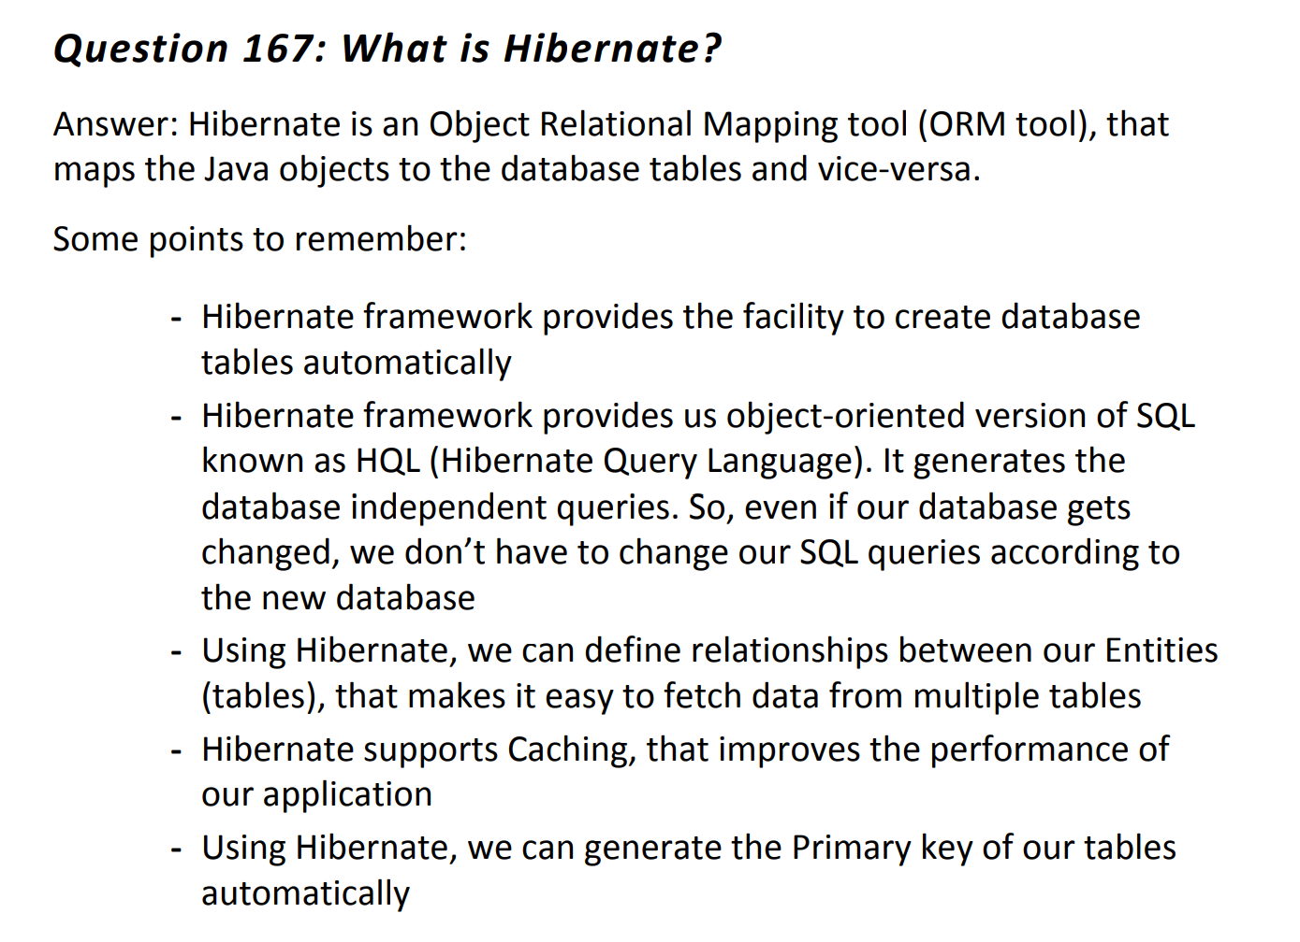

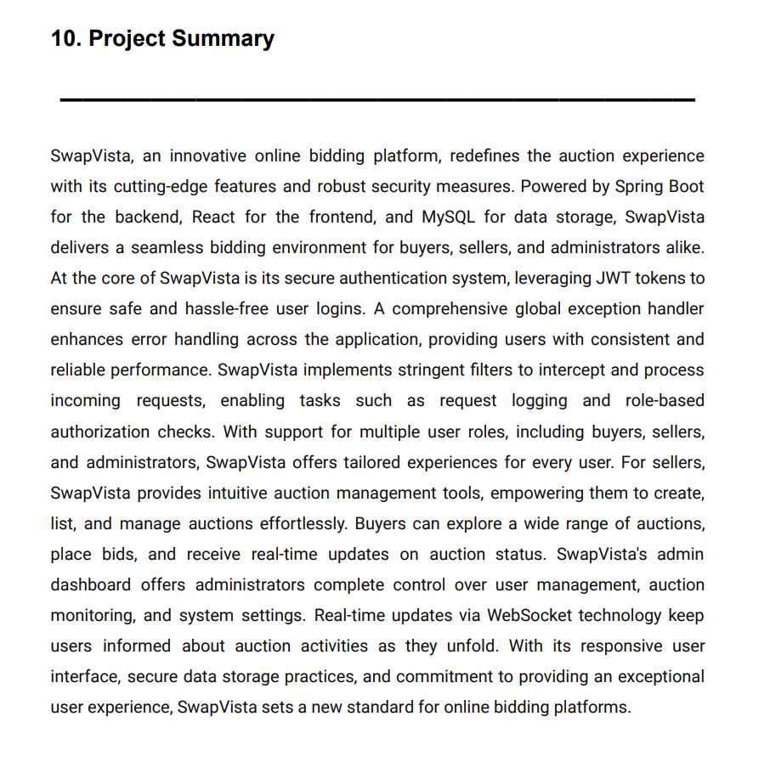

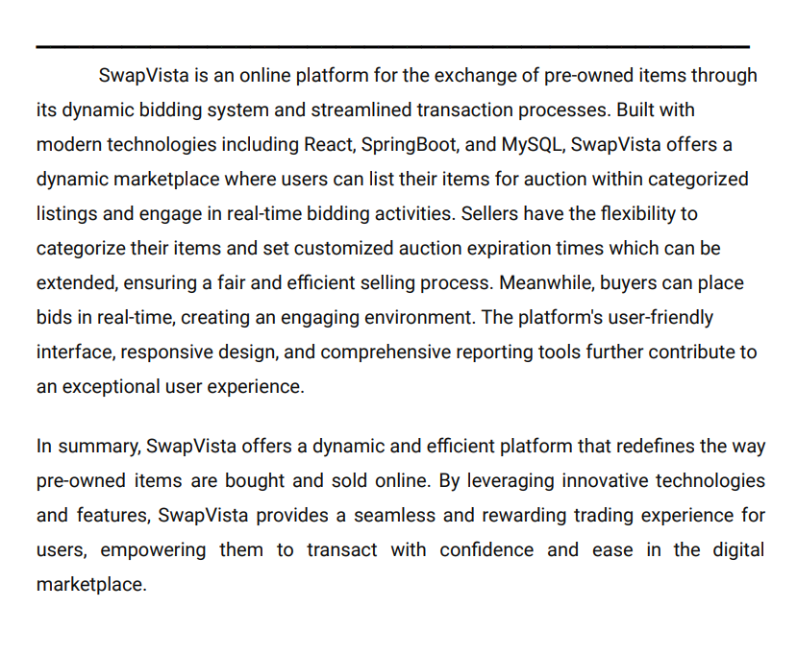

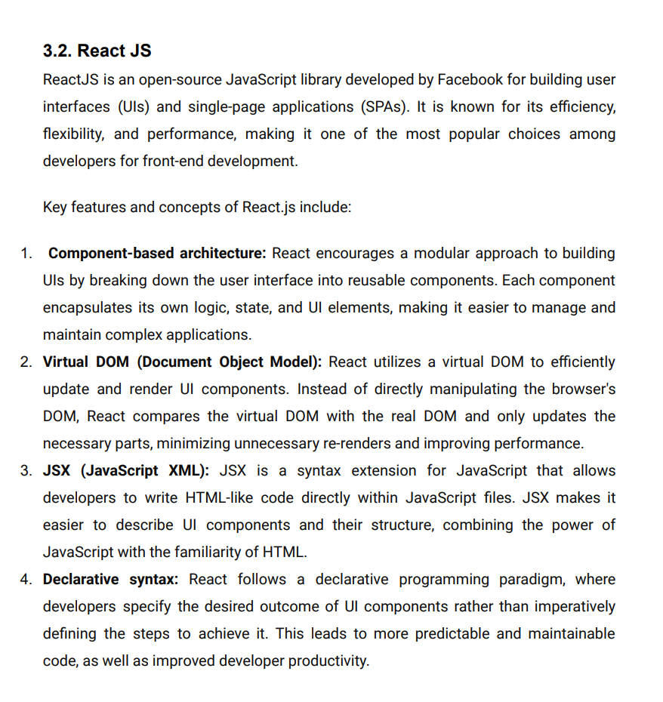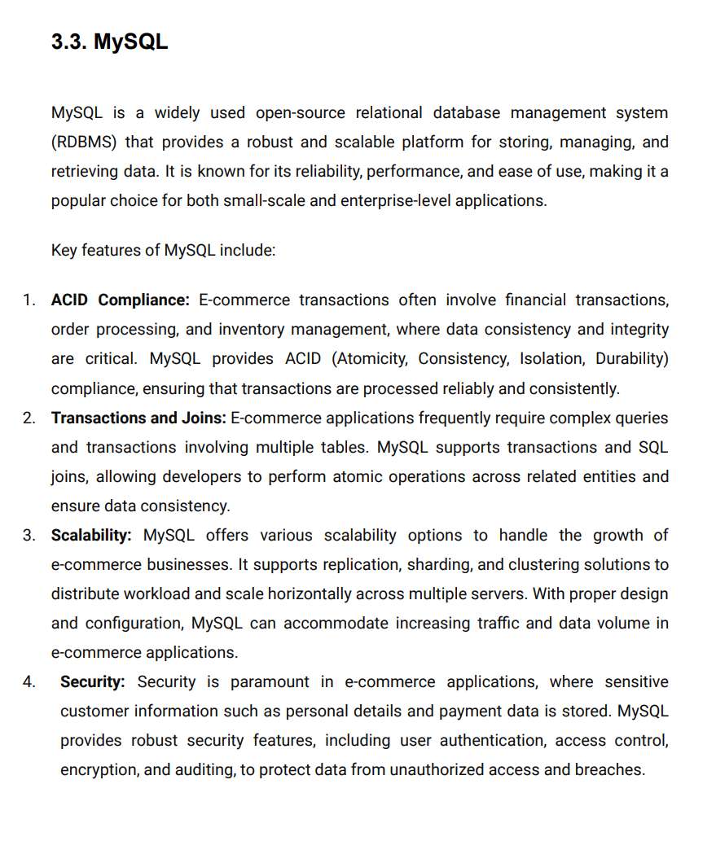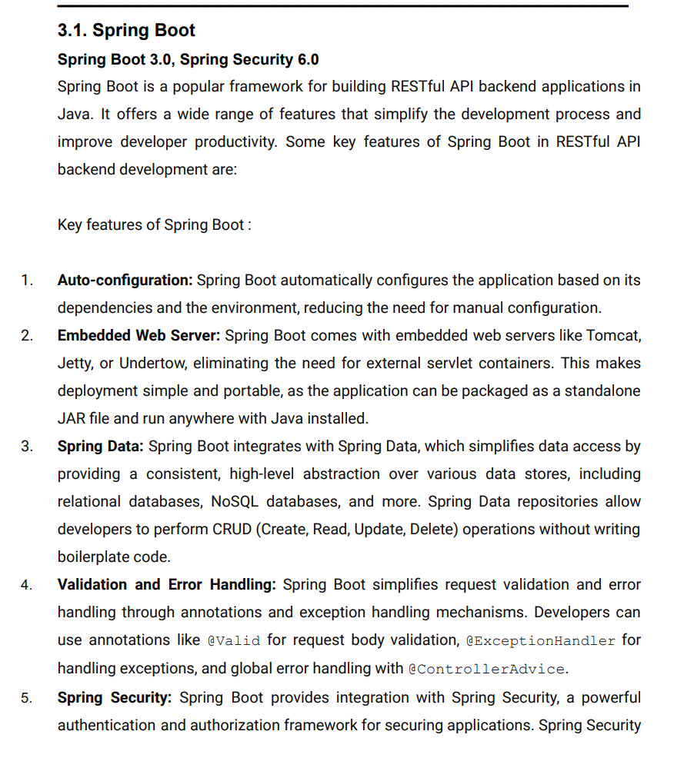

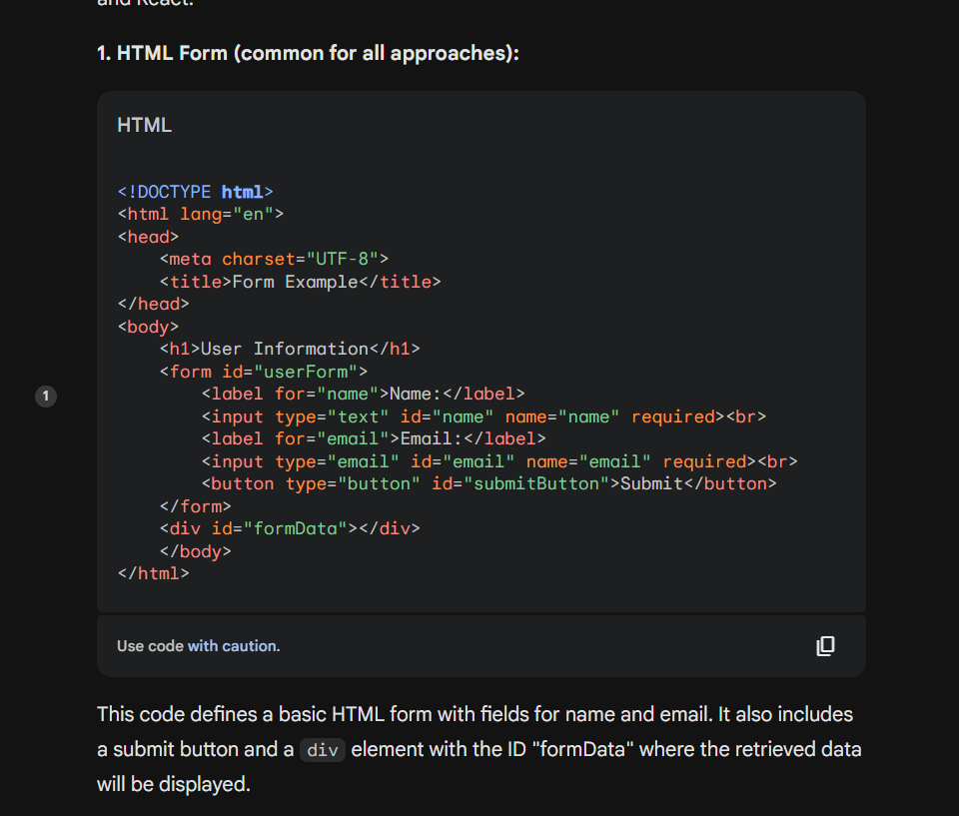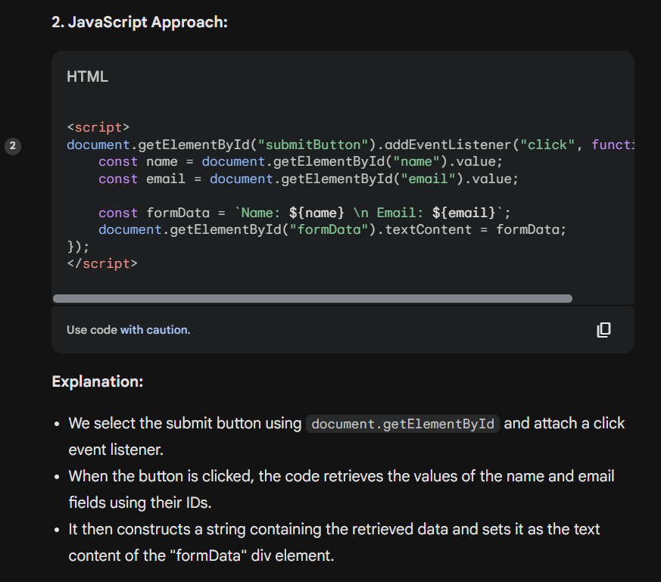

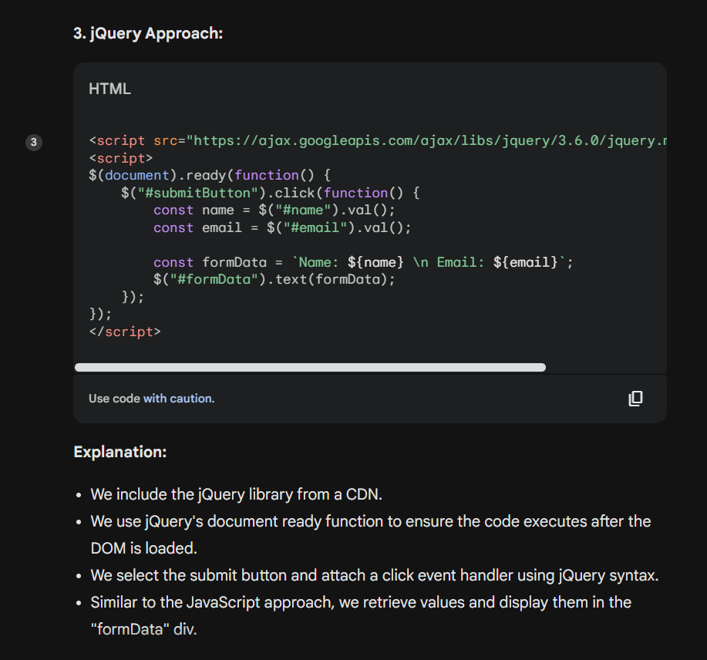

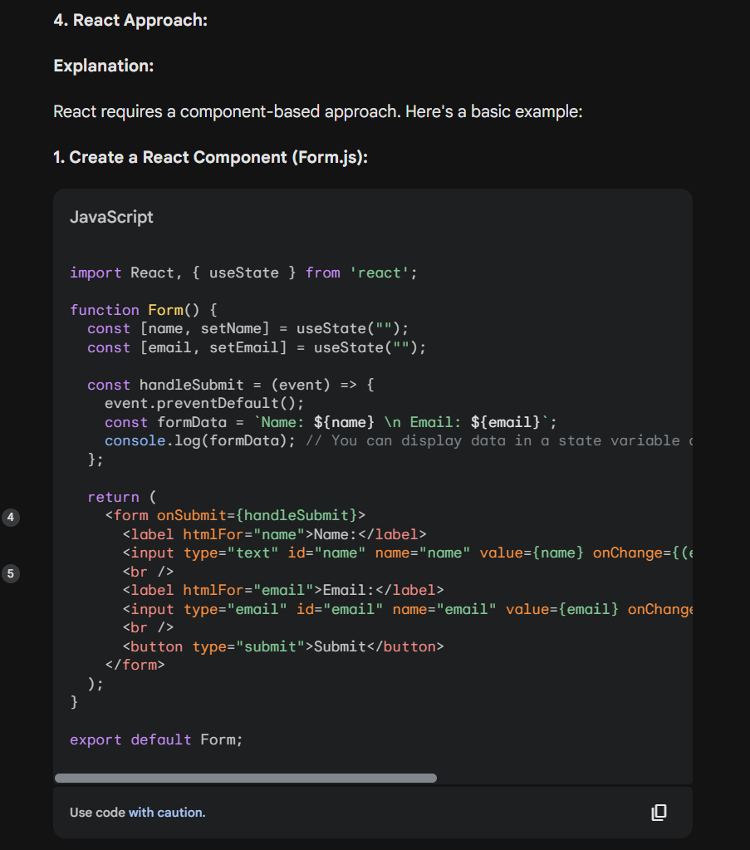

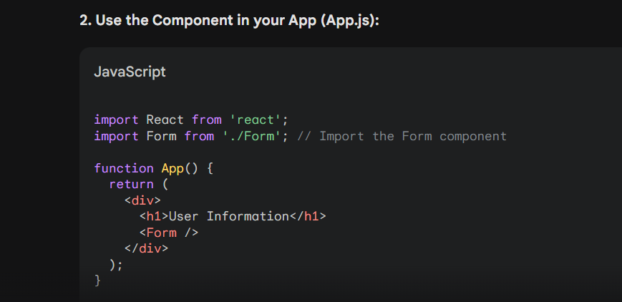

JWT

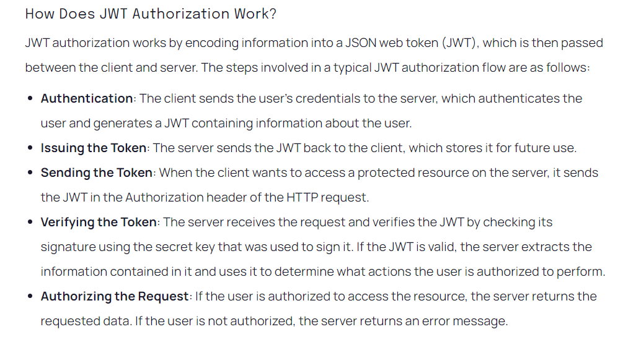

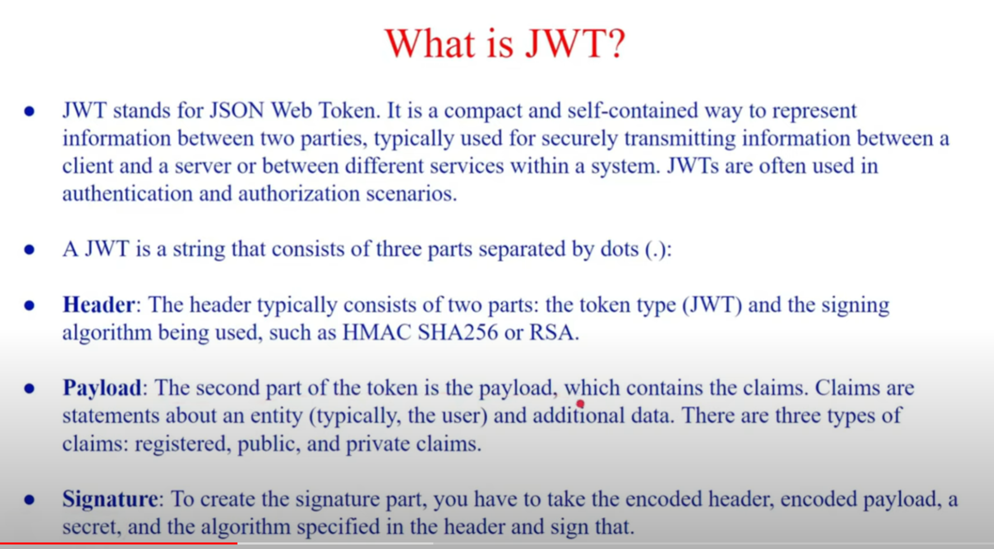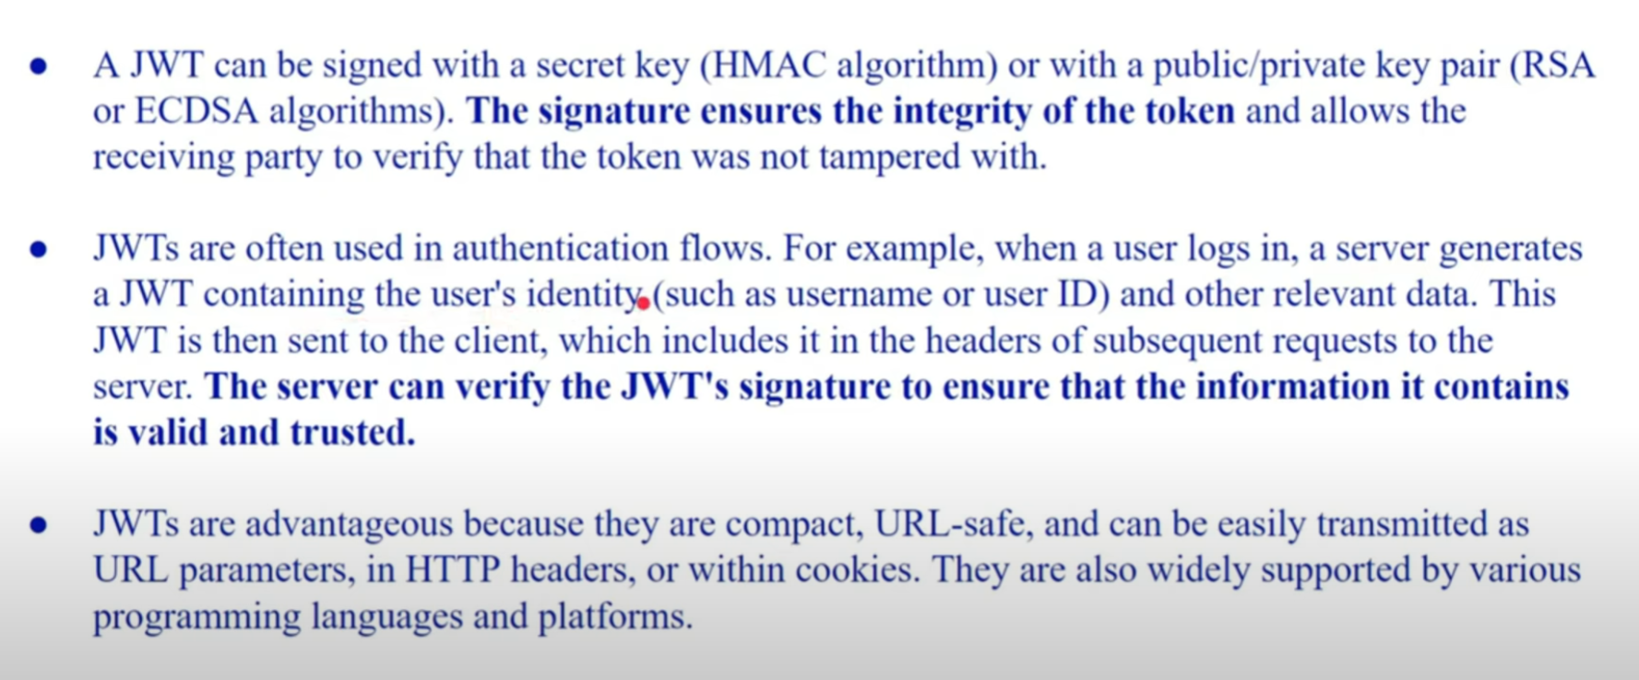

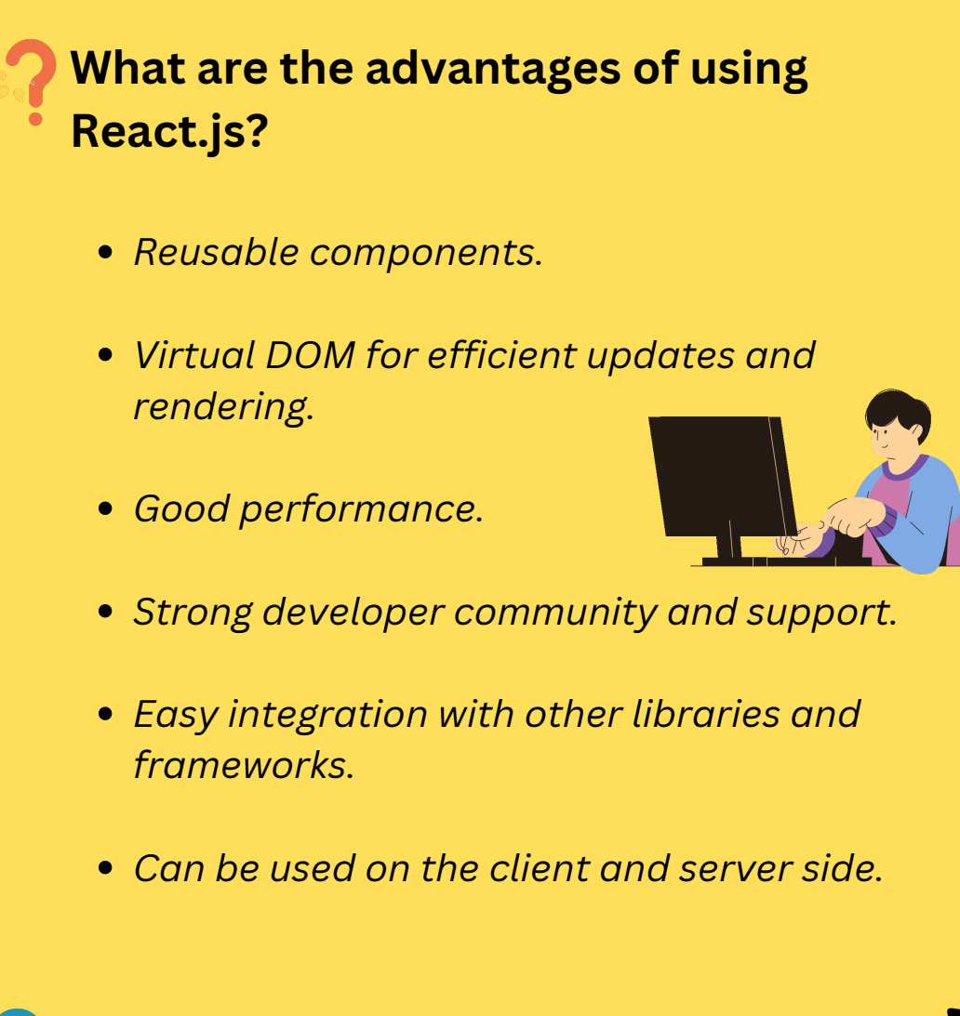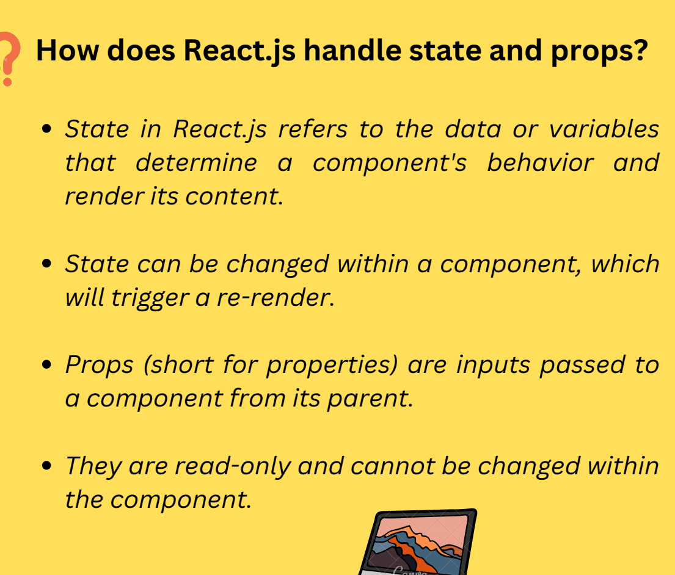

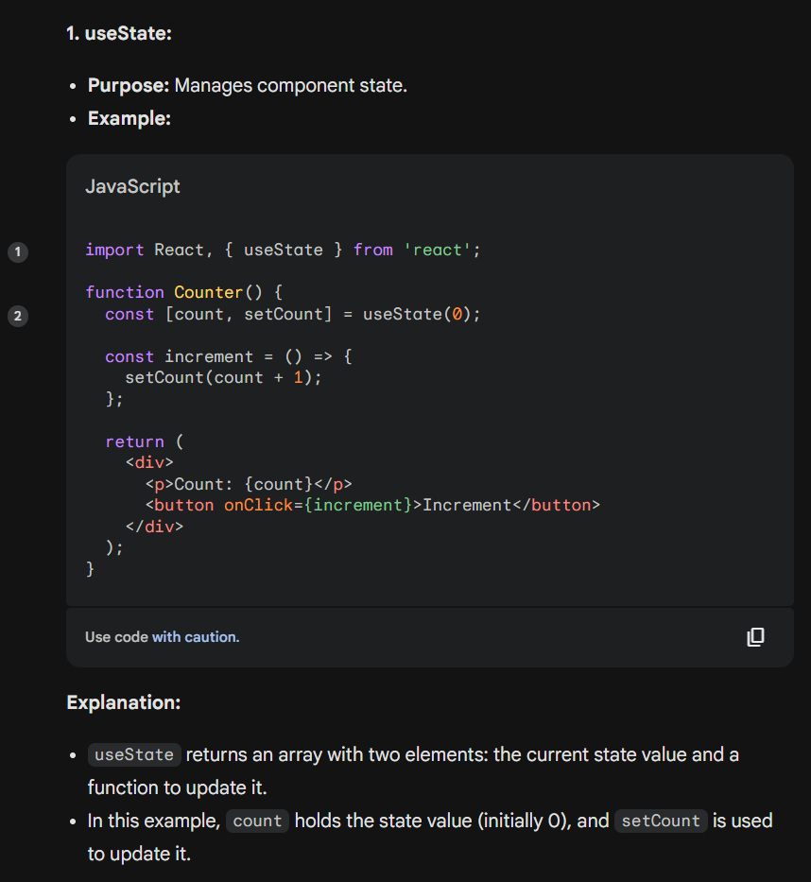

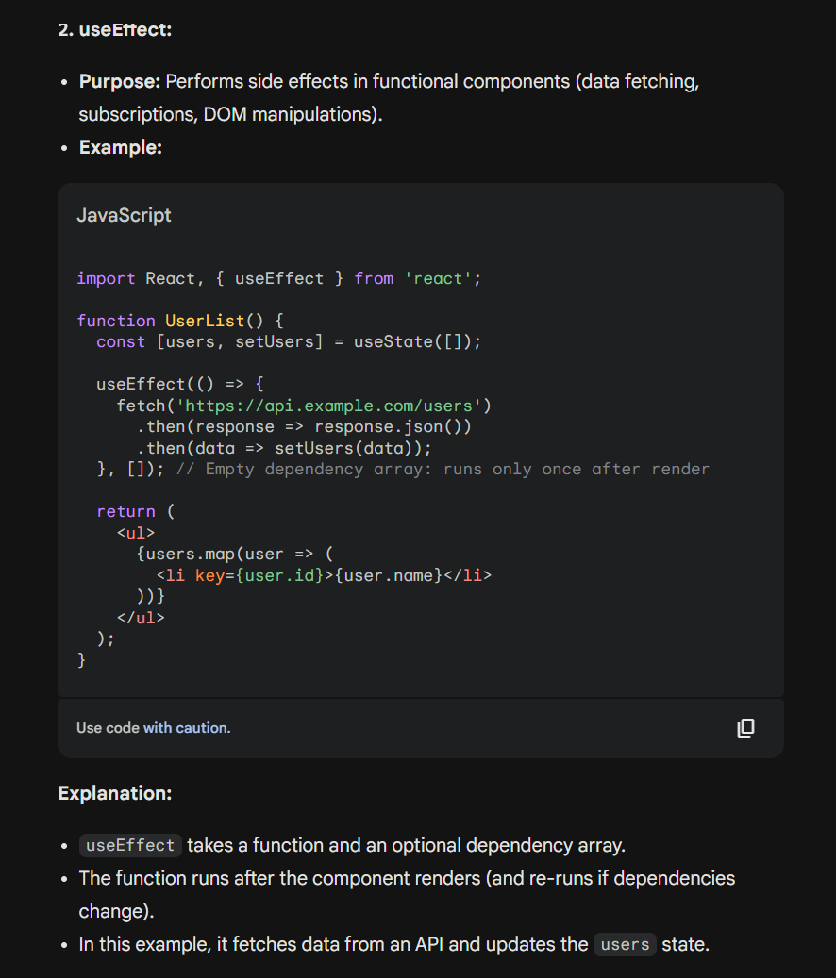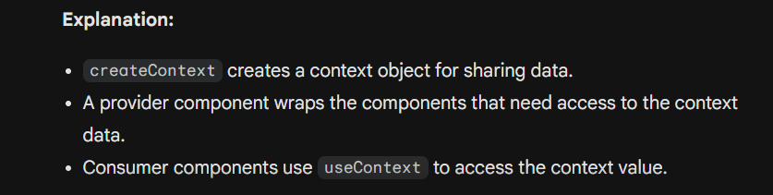

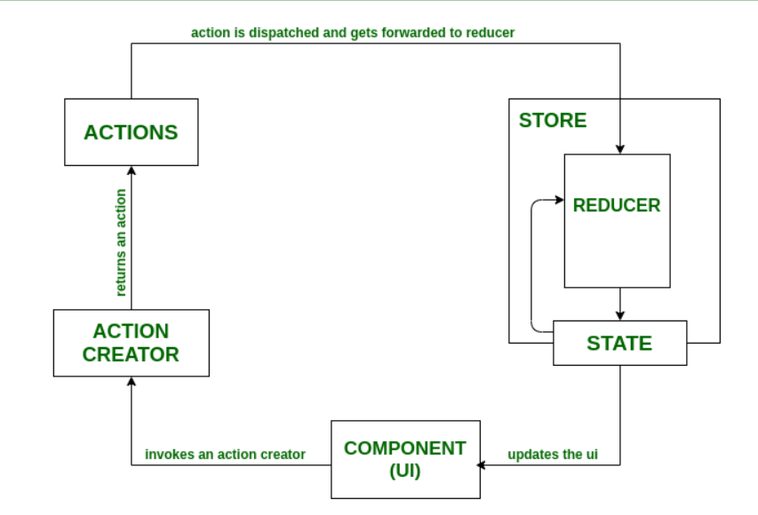

Project